Introductory Organic Chemistry Laboratory (CHM 361): Spring 2017

Sections 201 and 202 (CRN: 22409. 2410), 2:00 p.m., S-465, Monday and Wednesday

Credit: 3 hours Prerequisite or Co-requisite: CHM 356

**Instructor**: Dr. Lawrence R. Schmitz, Science 488, 696-2373, schmitz@marshall.edu

**Office Hours**: F: 1:00 – 2:00; T, Th: 2:00 – 4:00

**Required text**: Custom Laboratory textbook (Organic Chemistry Lab: version 2 for Marshall University) based on Pavia, D, Lampman, G, Kriz, G and Engel, R, *Introduction to Laboratory Techniques: A Microscale Approach, 5th edition*. The custom manual is available in the bookstore. The custom manual is designed to lighten the financial burden to students compared to purchasing the full text book.

**Other required items**: safety goggles, bound laboratory notebook, paper towels

**Recommended**: laboratory coat or apron

**Catalog Description:** An introduction to experimental organic chemistry with emphasis on fundamental techniques and their application to the preparation and identification of organic compounds.

**Learning Outcomes**: In this course you will:

1. perform and understand basic laboratory operations including purifying and identifying organic compounds, and carrying out organic reactions.
2. interpret experimental data.
3. do laboratory experiments that emphasizes and reinforces the principles and concepts of chemistry in CHM 355 and 356.
4. write a laboratory notebook

**Assessment:** Your ability to actually perform the basic laboratory operations will be accessed using product evaluations and the data in your laboratory notebook. Your ability to interpret data will be assessed in your laboratory notebook and in quizzes and exams. Your understanding of lab operations and the basic principles behind the experiments will be assessed using quizzes and exams. Your ability to keep a laboratory notebook will be assessed by actually collecting and grading sample of your notebook.

**Laboratory Policies:**

1. Anyone who has not signed the statement acknowledging one's full understanding of the required safety measures will not be permitted to work in the laboratory.

2. Use care in following the directions of your instructor and laboratory text. Do not alter the experimental procedures without being instructed to do so by the instructor or the TA’s.

3. Protective eye goggles must be worn in the laboratory at all times. Failure to do so will constitute sufficient grounds for dismissal from the laboratory. You are responsible for obtaining a pair of safety goggles. **We strongly urge you not to wear contact lenses.**

4. Clothing: Slacks or dresses cut below the knee must be worn. Shoes covering the bridge of the foot and toes must be worn. You will not be allowed to work while violating either of these rules.

5. Know the locations of all safety equipment in the laboratory. You will be tested on this.

6. All injuries, no matter how trivial, must be reported to the instructor immediately.

PASS THE SAFETY QUIZ ON MyMU BEFORE LAB (when it’s available)

**Course Policies:**

This course will be conducted adhering to university policies. Copies of these policies can be found at:

<http://www.marshall.edu/academic-affairs/policies/>

Academic dishonesty will not be tolerated. Students engaging in academic dishonesty will be sanctioned as per the university policy.

**Attendance**: Completion of all experiments and exams is required. Attendance is required.

**Making Up a Lab:** Only “Excused Absences”, as defined in the policy, can be made up. The proper procedure is to notify me (by e-mail, phone, or in person) as soon as possible; any documentation (such as doctor’s notes) have to be submitted directly to the Dean of Student Affairs (Dr. Stephen W. Hensley; MSC 2W38) who will then notify me. Note that one lab grade will be dropped in computing your score. If you miss a laboratory it will become your drop grade. If you miss more than one lab you will be give a zero on that lab if your absence was not excused. If you have excused absences for more than one lab and do not make them up during the week of the lab, you will be given an incomplete in the course so you can makeup the missed labs in a later semester.

**Grading:**

There will be two exams is this course. Accept for the first safety quiz, quizzes will be unannounced. Questions may concern material previously covered but will generally be concerned with the subject of the day. Late reports will be penalized 20% per day or part of a day that they are late.

**Course Grade:**

Your overall grade will be determined as shown below:

Laboratory Reports/Notebook: 30%

Product Evaluations 20%

Quizzes: 20%

Exams: 30%

__________________________________________________

Sub Total 100%

Based on a total of 100%, grades will be the highest grade possible on the following scale:

A ≥ 90%, B ≥ 80%, C ≥ 70%, D ≥ 60%, F < 60%

**Laboratory Report Grades:**

Technique: 10%, Results: 20%, Style, English: 20%, Completeness of the Report, logic etc.: 50%

(Note: The point value of labs requiring multiple periods will be weighted accordingly.)

**Product Evaluations:**

Certain labs (as indicated on the schedule) will require you to have your product or experimental results evaluated. You will hand in a product evaluation form and have your product inspected by an instructor.

**Schedule for Experiments.**

(May be subject to change, those changes if any will be announced)

|  |  |  |  |  |  |
| --- | --- | --- | --- | --- | --- |
| Date | Day | Technique | Exp # | Title | Report#/PE* |
| Jan 9 | M | **1** |  | Check-in |  |
| Jan 11 | W | **8, 11** | 3, 3A | Sulfanilimide | - |
| Jan 16 | M |  |  | MLK day | - |
| Jan 18 | W | 8, 11 | 3, 3B | Sulfanilimide | Jan. 25 |
| Jan 23 | M | **20** | handout | TLC (benzil, benzophenone, benzoin) | PE |
| Jan 25 | W | **12**, 20 | handout | Extraction of caffeine from Pepsi/Coke/Tea | PE |
| Jan 30 | M | 12, **14** | 23C | t-pentyl chloride | Feb. 6 |
| Feb 1 | W | 11 | handout | Solvolysis of Bromotriphenylmethane | PE |
| Feb 6 | M | 14 | 24, 24A | 4-Methylcyclohexene | - |
| Feb 8 | W |  | 24 | IR: 4-Methylcyclohexene | Feb. 15 |
| Feb 13 | M |  | handout | Hydrogenation | PE |
| Feb 15 | W |  | handout | Hydrogenation | PE |
| Feb 20 | M | 20 | handout | Reduction of Benzophenone w/NaBH4; TLC | Feb. 27 |
| Feb 22 | W |  |  | **Midterm Exam** | - |
| Feb 27 | M |  | 31, 31B | Camphor, Borneol, Isoborneol | - |
| Mar 1 | W |  | 31C | NMR: Borneol, Isoborneol | March 8 |
| Mar 6 | M | 11 | 41 | Nitration Methyl Benzoate | PE |
| Mar 8 | W | 11, 12 | 33, 33A | Grignard: Triphenylmethanol | - |
| Mar 13 | M | 11, 12 | 33. 33A | Grignard: Triphenylmethanol | PE |
| Mar 15 | W | 12, 14 | 14A | Banana oil (Isopentyl Acetate) | - |
| Mar 20 | M |  |  | Break |  |
| Mar 22 | W |  |  | Break |  |
| Mar 27 | M |  | 14A | IR: Isopentyl Acetate | April 3 |
| Mar 29 | W | 11 | 11 | Acetaminophen | PE |
| Apr 3 | M |  | 39, 39C | Wittig Reaction:  1,4-Diphenyl-1,3-butadiene | PE |
| Apr 5 | W |  | Handout | Deprotection of an Acetal | April 12 |
| Apr 10 | M |  | 46b, 32A | Nylon, Read Multistep Synthesis (page 56) and start Benzion preparation (32A) | Nylon - PE |
| Apr 12 | W | 11 | 32A,B; 37 | Continue Multistep Synthesis  (experiments 32A, 32B and 37) | - |
| Apr 17 | M | 11 | 32A,B; 37 | Continue Multistep Synthesis: Benzoin, Benzil, Tetraphenylcyclopentadienone | - |
| Apr 19 | W | 11 | 32A,B; 37 | Continue Multistep Synthesis | - |
| Apr 24 | M | 11 | 32A,B; 37 | Continue Multistep Synthesis | PE (worth 3X) |
| Apr 26 | W |  |  | **Final Exam** / Check-out |  |

* PE = product evaluation (the product of a synthesis or chromatograms or spectra are to be turned in for grading at the completion of the experiment)

# A date in this column indicates that a copy of your laboratory notebook as described below for the indicated experiment is to be turned in at the beginning of the period on the indicated date

The Laboratory Notebook

**1.** Authenticity, Credibility and Accuracy

When a scientist does an experiment, it is important that he or she keep accurate records of that experiment. These records are kept in a laboratory notebook. In this course, and in academic and industrial research laboratories, it is considered very important that you make every effort to insure that these records are accurate, relatively permanent, and not easily altered or modified. In addition to documenting what you did, your notebook should document when you did the work. To achieve these goals, you will be required to:

A. have a bound notebook with consecutively numbered pages;

(Spiral and loose-leaf notebooks are not acceptable since it is too easy to lose and/or delete or add pages. If your notebook does not have consecutively numbered pages, you should number the pages immediately.)

B. record your observations in permanent ink;

(Records done in pencil are too easily modified.)

C. record your observations and results directly into the notebook as you do the experiment;

(It is not acceptable to copy data on a piece of paper and then transfer the data to the notebook. It is very poor practice to record observations from memory after completing an experiment.)

D. clearly indicate the date that all work was performed;

(Each experiment should begin with a date. Your observations should be entered in chronological order. If the experiment continues for more than one day, a new date should be entered when further observations are made.)

E. correct any errors by drawing a single line through the error and then entering the correct data.

(*i.e.* “The reaction mixture was heated at the boiling point of the solvent for ~~35~~ 45 minutes.”)

(Erasures are not acceptable.)

**2.** Style and Grammar

Most scientific writing uses the past tense and passive voice, and avoids first person statements. This style of writing may not be as natural to you as using the first person, active voice. However, it is the most accepted style of scientific writing and you should use this style. The procedure and observations section for each experiment should describe the experiment that you did. It should not be a set of instructions describing how to do the experiment. Some examples follow.

(Incorrect) First person, active voice:

“I transferred the reaction mixture to a separatory funnel and then I washed it with two 15 mL portions of 10% NaOH.”

(Incorrect) Instructions:

“Transfer the reaction mixture to a separatory funnel and wash it with two 15 mL portions of 10% NaOH.”

(Correct) Passive voice:

“The reaction mixture was transferred to a separatory funnel and washed with two 15 mL portions of 10% NaOH.”

**3.** Contents

The cover or first page of laboratory notebooks should be clearly labeled with the name of the investigator. Since you will be required to hand in copies of each of your experiments, you should also put your name at the beginning of each experiment. You should leave one or two pages blank at the beginning of the notebook so a table of contents can be added.

The format of the entries for individual experiments will vary depending on the type of experiment. In this course, the objectives of the experiments fall in to three groups, isolation or purification of organic compounds, preparation of organic compounds, and identification of organic compounds. Suitable formats for each of the three types of experiment are shown below.

Notebook Format for Purification or Separation Experiments

Your Name Date

Title

I. Introduction

a. purpose

b. data table with references

(See Technique 29, Guide to the Chemical Literature, in your laboratory manual for examples of how to cite references)

II. Experimental (You should describe the experiment as you did it. Include sufficient detail so that another person with a similar chemical background to your own could repeat the work without referring to the text. Record any observations made during the experiment.)

III. Results and Discussion

IV. Conclusions

V. Exercises or Assigned Questions

Notebook Format for Synthetic Experiments

Your Name Date

Title

I. Introduction

a. purpose

b. a balanced equation for the main reaction

c. the mechanism of the main reaction

d. equations for any significant side reactions

e. data tables with references (You may find it useful to prepare two or three tables; one for reactants, one for products, and one for side products, solvents, catalysts etc. Each of these tables should include the molecular weight and physical properties for each compound. The reactants table should also include the amount used in the appropriate measured quantity (usually grams or milliliters) and in moles. The products table should also include the amount of product obtained, the theoretical yield and percent yield. These tables should be prepared before the laboratory period. However, you should leave blank space for the amounts used and obtained. This data can be added at the appropriate time.)

II. Experimental

(You should describe the experiment as you did it. Include sufficient detail so that another person with a similar chemical background to your own could repeat the work without referring to the text. At this point in the course, you may assume that the reader has had an introduction to the techniques for isolation and purification of organic compounds. Suppose that a fractional distillation is required to purify the products of a synthetic reaction. It is unnecessary to describe the details of how to do a fractional distillation. You may assume the reader knows how to assemble the glassware, position the thermometer and regulate the water flow through the condenser etc. The type and length of column used in the distillation should be included in the notebook since this varies from one experiment to another. Record any observations made during the experiment.)

III. Results and Discussion (In addition to the usual discussion of the experiment, this section should contain a detailed calculation of the theoretical and percent yields for the synthesis.)

IV. Conclusions

V. Exercises or Assigned Questions

Notebook Format for Qualitative Analysis Experiments

Your Name Date

Title

I. Introduction

(Your introduction should include a discussion of the classification tests and derivatives that can be used to identify the type of compounds given as unknowns. Include balanced equations were appropriate.)

II. Experimental

(You should do all of the relevant classification tests and the preparation of at least two derivatives. You should describe the experiments as you did them. Include sufficient detail so that another person with a similar chemical background to your own could repeat the work without referring to the text. You should include a brief description of what was actually observed during classification tests. That is, it is not adequate to say that you did a test and it was positive or negative. Describe the observed result and then draw the appropriate conclusions as to whether the test was positive or negative.)

III. Results and Discussion

(This section should present an overview of the logic you used to identify the unknown and needs to be expanded considerably from previous experiments. Include a table of the classification tests done and the results. Point out the conclusion drawn from each classification test performed. In some situations, you will need to draw conclusions based on more than one test. Based on the boiling point or melting point of your unknown and the results of the classification tests, you should prepare a list of possible compounds that could be your unknown. Point out how you used the derivatives to identify the unknown. Any inconsistencies in your data should be discussed.)

IV. Conclusions

(Identify the unknown and include the unknown number. If you cannot identify the unknown, do not guess. Unsupported conclusions will be penalized if they are right or wrong. If you can limit the unknown to a list of possible compounds, do so.)

Larry Schmitz Jan. 11, 2001

Synthesis of n-Butyl Bromide

I. Introduction

The purpose of this experiment is to prepare a sample of n-butyl bromide according to the following equation:

CH3CH2CH2CH2OH + NaBr + H2SO4 ------> CH3CH2CH2CH2Br + H2O

+ NaHSO4

The reaction proceeds via an SN2 substitution on the protonated alcohol as shown below.

CH3CH2CH2CH2OH + H2SO4 ------> CH3CH2CH2CH2O+H2 + HSO4**-**

CH3CH2CH2CH2O+H2 + Br **-**  ------> CH3CH2CH2CH2Br + H2O

Side reactions that might accompany this reaction are elimination to form an alkene and/or condensation to yield and ether.





Table of Reactants

Compound Molecular. Literature Density1 Amount Used

Wght. b.p. or m.p.1

1-butanol 74.1 117.2 °C (b.p.) 0.8098 g/mL 1.4 mL

(1.1 g, 0.015 mol)

sodium bromide 102.9 747 °C (m.p.) 2.4 g (0.023 mol)

1 Data from: R.C. Weast, ed. Handbook of Chemistry and Physics. 70th ed. Boca Raton, FL: CRC Press 1989.

Date your work.

Title each experiment.

a brief statement of purpose.

a balanced equation.

mechanism.

Write the introduction before lab.

side reactions.

Data Tables.

Include references to appropriate literature.

Table of Products and Side-Products

Compound Molecular Literature Density2 Amount Obtained

Wght. b.p. 2

n-butyl bromide 137.0 101.6 °C 1.2758 g/mL 1.709 g

(0.01247 mol)

1-butene 56.1 -6.3 °C

Di-n-butyl ether 130.2 142 °C 0.7689 g/mL

2 Data from: Weast, R.C. (Ed.) CRC Handbook of Chemistry and Physics; 70th ed.; CRC Press: Boca Raton, FL, 1989.

II. Experimental

The synthesis was carried out using the method of Pavia, Lampman, Kriz and Engel. Pavia, D. L.; Lampman, G. M.; Kriz, G. S.; Engel, R. G. Introduction to Organic Laboratory Techniques, a Microscale Approach; 3rd Ed.; Saunders: New York, 1999.

To a preweighed 10 mL round-bottom flask was added 1.4 mL of 1-butanol.

Wght. of Flask: 19.657 g

Wght. of Flask and 1-butanol: 20.791 g

Wght. of 1-butanol: 1.134 g

2.4 g of sodium bromide and 2.4 mL of cold water were added to the 1-butanol. The mixture was cooled in an ice bath and 2.0 mL of concentrated sulfuric acid was added dropwise. The flask was attached to a reflux apparatus with an HBr trap as shown below. The mixture was stirred, heated to it's boiling point and allowed to reflux for ~~65~~ 70 minutes.

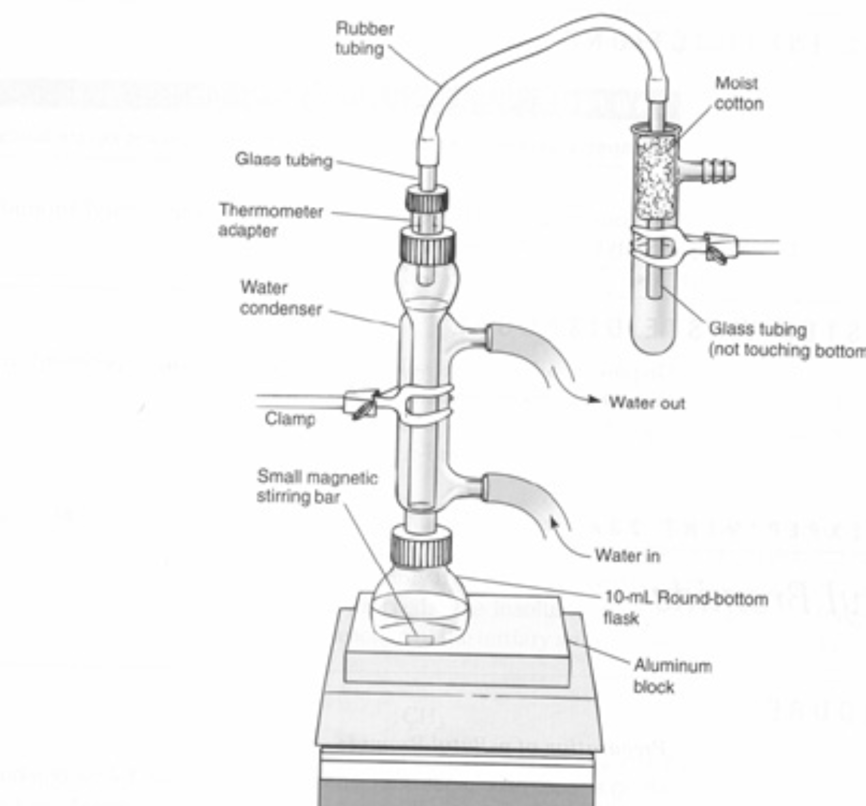

Amounts used and obtained should be filled in when you do the experiment.

The experimental section should be written in the laboratory.

References should be included in the body of the notebook but at the end of reports or papers.

Correct errors by crossing out with a single line.

Use diagrams if they help make your meaning clear.The reaction mixture was allowed to cool until the apparatus could be touched without burning oneself. Two layers formed in the flask. Most of the lower layer was removed with a Pasteur pipet. A drop of water was added to the lower layer and was found to be miscible with the lower layer. The lower, aqueous, layer was discarded. The upper layer was transferred to a 5 mL conical vial and a small amount of additional aqueous layer was removed with a Pasteur pipet. The remaining layer was extracted with 2 mL of 9M sulfuric acid by adding the acid to the vial, gently shaking, venting, allowing the layers to separate and removing the bottom layer with a Pasteur pipet. A drop of water added to the bottom layer was miscible with it confirming that is was the aqueous layer. The aqueous layer was discarded. 2 mL of water was added to the organic layer, the vial capped, shaken and the layers allowed to separate. The lower layer was removed and placed in a clean vial. As expected the upper layer was miscible with an added drop of water. The upper layer was discarded. The organic layer was washed with saturated aqueous sodium bicarbonate by adding 2 mL of the bicarbonate solution to the organic layer in several portions, capping and shaking the vial with frequent venting. The layers were allowed to separate and the lower layer was removed and placed in a clean vial. The upper layer was miscible with water and was discarded. Three microspatula fulls of anhydrous sodium sulfate was added to the organic layer, the vial capped and allowed to stand for about 5 minutes until the organic layer was clear. The organic layer was transferred to a clean and dry distillation apparatus consisting of a 3 mL vial and a Hickman still head as shown below. The distillation apparatus was heated with a hot plate. The product was periodically removed from the Hickman still as it distilled and placed in a clean preweighed vial. The distillation was discontinued when only a drop remained in the distilling vial.

Wght of the vial: 35.350 g

Wght of the vial and product: 37.059 g

Wght of the product: 1.709 g

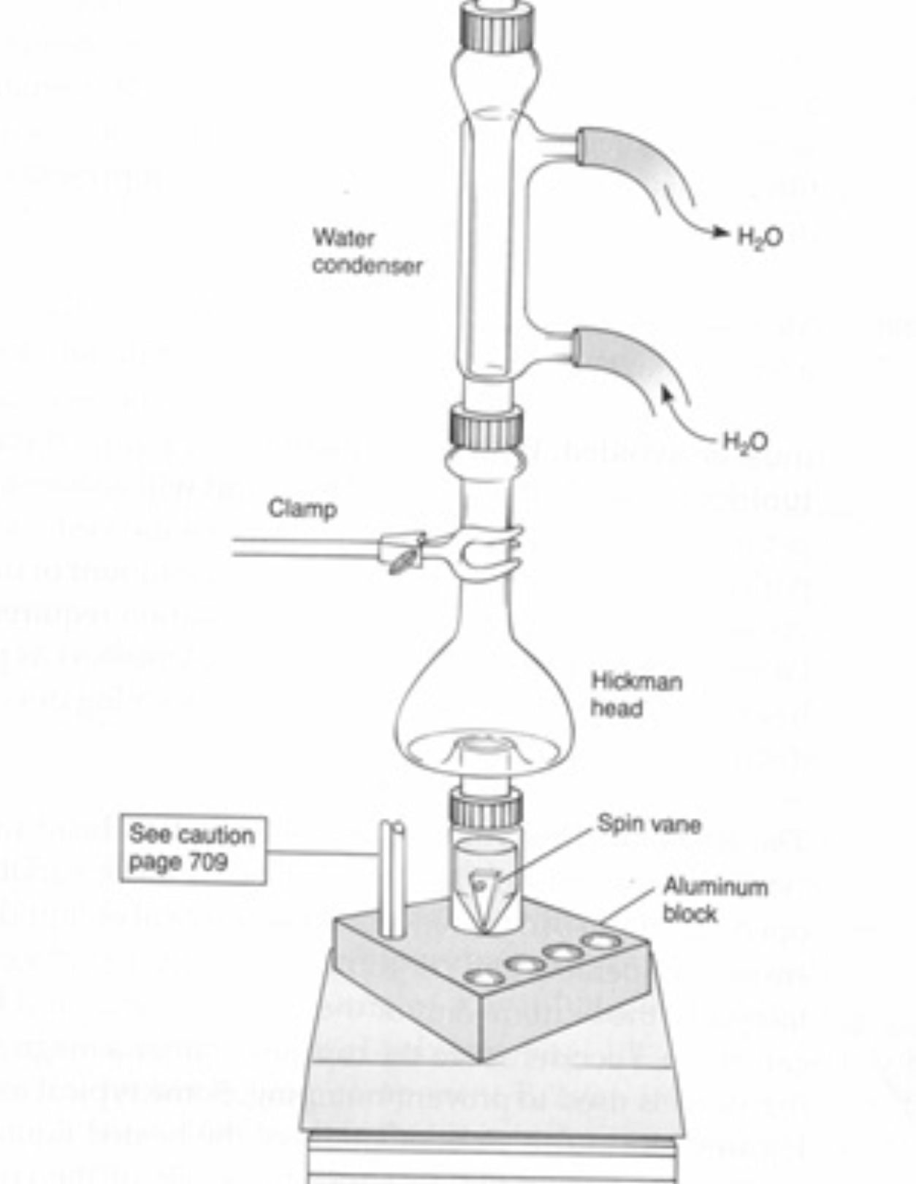

Included your observations in the experimental section.

Use the passive voice and past tense when describing the work you did.

Record data in your notebook as you do the experiment.

Use diagrams if they help make your meaning clear.January 12, 2001

The boiling point of the purified product was obtained using the microscale boiling point procedure of Pavia et. al., and was found to be 101 °C. Pavia, D. L.; Lampman, G. M.; Kriz, G. S.; Engel, R. G. Introduction to Organic Laboratory Techniques, a Microscale Approach; 3rd Ed.; Saunders: New York, 1999, pp. 586-589. The infra-red spectrum of the product was obtained as a thin film of a neat sample between silver chloride plates using a Midac model M1700 Fourier transform spectrophotometer.

III. Results and Discussion

Calculations:

Moles of 1-butanol = 1.134 g (1 mol / 74.1 g) = 0.01530 mol

Moles of sodium bromide = 2.4 g (1 mol/102.9 g) = 0.023 mol

Moles of sulfuric acid = 2.0 mL (1L /1000 mL) (18 mol/L) = 0.036 mol

Since the stoichiometry is 1:1:1 the limiting reagent is 1-butanol.

Theoretical Yield = 0.01530 mol butanol (1 mol butyl bromide/ 1 mol butanol)

(137.0 g/mol) = 2.096 g

% Yield = (1.709 g / 2.096 g) 100% = 81.53%

The product, n-butyl bromide, was obtained in relatively high yield (81.53%). Allowing for some loss of the actual product during purification, this means that only small amounts of the expected side products could have formed. The observed boiling point and IR spectrum indicate that the product was relatively pure. The observed boiling point was close to the literature boiling point (101 vs. 101.6 °C, respectively). Allowing for the fact that atmospheric pressure in Huntington is generally slightly less than 760 mm Hg, this is good agreement. The IR spectrum does not show bands that would be expected if the product were contaminated with starting material or side products. The absence of OH stretching bands (3200 - 3500 cm-1), C=C (1640 -1670 cm -1), and =C-H stretches (3020 - 3100 cm-1), and C-O stretches (1050 - 1250 cm-1) demonstrate the lack of substantial amounts of 1-butanol, 1-butene, and di-n-butyl ether, respectively.

IV. Conclusions

Relatively pure n-butyl bromide was obtained in 82% yield from the reaction of 1-butanol and sodium bromide catalyzed by sulfuric acid.Be sure to keep the date correct. Update as needed

Be sure to include enough detail to allow the reader to repeat your spectral work as well as your synthetic work.

calculations

discussion

brief conclusion