SYLLABUS
ISC 280: LIVING ON THE EARTH
SPRING 2008

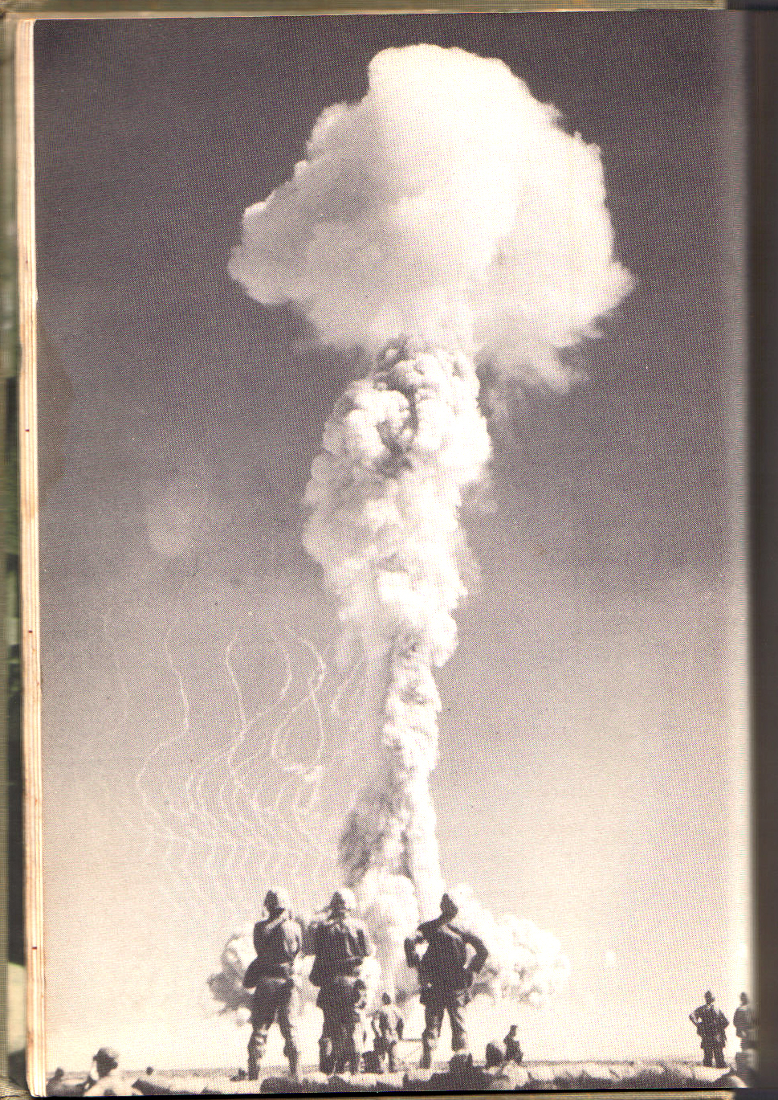

Instructor: Terry Shank
Office: Room 201, Science Bldg. Hours: M-12-1:45, 4:30-6; W-1-2, 4:30-6; F-3-6
Phone: Office: 696-3480 email: shank@Marshall.edu

COURSE DESCRIPTION:
The title “Living on the Earth” is a rather nebulous phrase that intends to combine the disciplines of Biology, Chemistry, Physics, Geology, Mathematics, Astronomy, Anthropology and other sciences in an effort to identify and explain problems that have the potential to alter environments on the Earth. Many of these problems/conditions are the sole responsibility of the human inhabitants, yet others come from far beyond the reach of human hands. The focus of this course will be on humans as agents of evolution (if we may be so bold as to assume), agents of species dispersal, agents of extinction and agents of perturbation of the Earth’s many ecosystems structure and function.

COURSE OBJECTIVES:
1) The student will learn the methodology of science, stressing the significance of the “Scientific Method’ as a means of obtaining meaningful information about the diversity and unity found on the Earth.
2) The student will learn how to apply scientific skills to allow him to better distinguish fact from fiction, hearsay and myth in order to discern the value of ‘scientific’ information that is being supplied for his consideration.
3) The student will learn to interpret and apply statistical data sets as presented in charts, graphs, etc., reflecting skills developed from a prerequisite math class.
4) The student will learn to refine competencies of research and analysis into both writing and oral presentations.
5) The student will learn some of the fundamental concepts of physical and biological science.
6) The student will learn the fundamental concepts of ecology and environmental science.
7) The student will learn the perspective of man’s historic role in the alteration of his environment
8) The student will learn a prospectus of current human activities with respect to the effects these activities have on the environment
9) The student will learn about sources of change that lay beyond the influence of human activities

COURSE OVERVIEW:
- Fundamentals of science and the Scientific Method
- Fundamentals of Ecology
- Forces of change from within the Earth…and from without
- The environmental role of fire, water and weather as agents of change
- Dynamics of Hominids, including Homo sapiens
- The consequences of culture among primitive humans and the spread of civilization
- The effects of pollution on the environment, and the effects of the environment on pollutants
- The choices facing modern man, environment verses economics

There is no text for this course, so you will be provided with readings and websites as sources of information to augment lecture material. There is a plentiful supply of information, so it will be your responsibility to research and read information from these sites as they are presented to you. You will be held responsible for all classroom and lab activities. In accordance with University policy, please communicate with me via your Marshall University email address in order to avoid release of sensitive information to third parties. Assignments will also be provided through your MU email address.

COURSE EVALUATION
Classroom activities will be evaluated in the form of two (2) tests. Occasional exercises will also be graded for points, and will be used to emphasize specific lecture content and/or current events as they may arise. The mechanics of this course make it difficult to offer ‘makeup tests’, so only special requests and excused absences will be allowed. There are no provisions to makeup classroom activities, quizzes and labs. To get full credit for these activities, attendance is mandatory. As an incentive, Lecture and lab materials will be emphasized on exams. Evaluation of lab participation, two writing assignments of three pages each, outside assignments, using a variety of methods, including-but not limited to-quizzes, class participation, research opportunities and a group presentation (as explained below) will constitute the additional points used for student evaluation. All labs will be graded for points, with some labs, such as off-campus field trips, carrying more point value than others. You will need to bring a calculator for several of the labs.

GROUP PRESENTATION
Each student will participate in a group presentation based on a subject selected by yourself or your instructor. Each group will consist of no less than two nor more than four students. These presentations will be made during the final lab sessions. It will be worth a total of 100 points for each participant. A corresponding three page paper dealing with each student’s individual portion of the presentation will be due at the time of the group’s presentation. Specific instructions will be emailed at a later date.

CLASS ASSIGNMENTS
Websites and readings will be provided on a regular basis as required reading. Access to a computer is therefore a necessity. Please come to each class prepared for discussion of these assignments. Email assignments will also be given when appropriate, and will not be repeated by me in future class sessions. This will require your attendance or inquiry from other students to get the assignments and due dates. I will regularly communicate with you through your Marshall email account, so make it a habit to check it on a regular basis.

LECTURE SCHEDULE: (SUBJECT TO CHANGE/REFINEMENT)

JAN. 14: Introduction, Expectation-Yours, Mine and Ours, Discussion
JAN. 16: Science and the Scientific Method

JAN. 21: MLK BIRTHDAY- NO CLASS

JAN. 23: ‘Reality, What a Concept’- the nature of matter and energy

JAN. 28: Nitpicking Reality- atoms, molecules, bonds and such

JAN. 30: An Investigation of Energy

FEB. 4: The Theory of Evolution; Science verses Non-science Paper Due

FEB. 6: The Structure of the Earth, Mineral Resources

FEB. 11: Earthbound Energy Resources

FEB. 13: Non-renewable verses Renewable Energy

FEB. 18: Soil and Food Resources

FEB. 20: Pesticides

FEB. 25: Principles of Population

FEB. 27: Human Population, Problems of Distribution

MAR. 3: MIDTERM

MAR. 5: Solid and Hazardous Wastes; Waste Diary Due

MAR.10: Weather, Climate and Heat Distribution, air as a Resource

MAR. 12: Air Pollution

MAR. 17: Air Pollution

MAR. 19: Climate Change

MAR 23 & 25: SPRING BREAK, NO CLASSES

MAR.31: Water Resources, Freshwater

APR. 2: Water Resources, Saltwater

APR. 7: Water Pollution

APR. 9: ASSESSMENT DAY, NO CLASS OR LABS

APR. 14: Environmental History of USA

APR. 16: Biodiversity

APR. 21: Sustainability, Wild Species

APR. 23: Sustainable Cities-Urban Land Use

APR. 28: Economics and Environment

APR. 30: Politics and Environment

MAY 5: FINAL- 3:00 IN LECTURE ROOM

LAB SCHEDULE: (SUBJECT TO CHANGE/REFINEMENT)

LAB 1: Introduction, lab safety, film

LAB 2: Scientific Method

LAB 3: Group formation, research questions

LAB 4: Evolution, film

LAB 5: Geology Scavenger Hunt

LAB 6: Campus Energy Waste

LAB 7: Earth’s Carrying Capacity- bring calculator

LAB 8: Population Growth

LAB 9: Population distribution

LAB 10: Biomes, film

LAB 11: SPRING BREAK, NO LABS

LAB 12: FIELD TRIP TO BEECH FORK (or film if weather uncooperative)

LAB 13: ASSESSMENT DAY, NO LABS THIS WEEK

LAB 14: Tree identification / key (or film if weather uncooperative)

LAB 15: GROUP PRESENTATIONS

LAB 16: GROUP PRESENTATIONS

