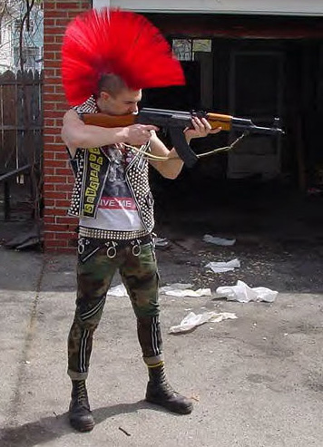

Marshall University

Department of Criminal Justice

CJ 483/583: Youth Subcultures, Groups, and Lifestyles: International Societal and Police Response
Intersession 2011

Spring 2009

CJ 483/583: Youth Subcultures, Groups, and Lifestyles: International Societal and Police Response May/June 2011 3.0
Course Number & Title Semester/Year Credits

Dr. Gordon A. Crews Phone: 304.696.3083 (Voice Mail) Office: Harris Hall 236 Email: crewsg@marshall.edu

Professor

Class Hours, Days, & Room: MTWTH 1:00 to 3:45pm Office Hours & Days: TBA and by appointment

REQUIRED TEXT: There is no required text for this course (Use your money for copies, research materials, gas, weapons, bail, and other items you may need!).

COURSE DESCRIPTION: Specialized courses of contemporary interest. The purpose of this course is to examine various youth subcultures, groups, and lifestyles around the world. Youth as a social phenomenon arose largely as a cultural derivative of the industrial revolution in Europe and the USA and is now global. In the twentieth century particularly, youth became an object of sociological, cultural, and psychological analyses. The concept of ‘subculture’ has been used with various degrees of success to analyze youths’ individual and collective behaviors. This course surveys some of the many strands of youth-subcultural theory during the twentieth century. It then moves on to examples of contemporary Subcultural theory and research, focusing on a number of discrete sociological concepts and youth-Subcultural groups.

COURSE OBJECTIVES: Upon completion of this course, the student should be able to:

- To familiarize students with the worth of ‘subculture’ as an analytic concept as well as the various concepts that drive Subcultural studies.
- to familiarize students with various strands of Subcultural theory in sociology and cultural studies
- to review a variety of historical and contemporary youth subcultures as well as the concepts and methods used to study them
- to improve students’ understanding of how and why youth subcultures emerge, exist, and change

DEPARTMENT OF CRIMINAL JUSTICE STUDENT LEARNING OUTCOMES

- Describe and apply basic criminal justice information and concepts
- Demonstrate critical thinking and problem solving skills relevant to criminal justice
- Use appropriate social science and/or legal research and skills and resources to complete original research in criminal justice
- Effectively communicate in both oral and written formats using discipline-appropriate vocabulary and dialogue
- Recognize and apply ethical principles of the discipline in regard to research, use of sources, collaboration with colleagues, and principled decision/policy making
- Successfully enter into discipline-appropriate employment as a professional in criminal justice or, if desired, continue education in graduate and/or law school
- Demonstrate comprehension of discipline-appropriate technology, including computer hardware and software

GRADING SCALE:
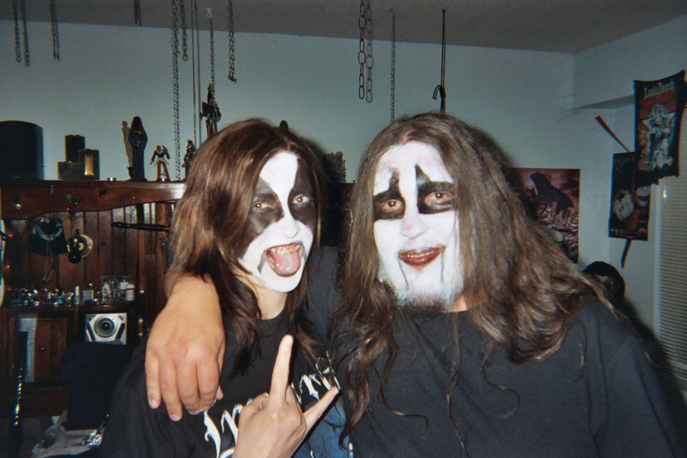
A = 90 – 100
B = 80 – 89
C = 70 – 79
D = 60 – 69
F = 59 and below

UG Course Requirements and Score Sheet
Requirement | Points | Due Date
Films Analysis (3 weeks x 100) | 300 | May 16, 2011  May 23, 2011  May 31, 2011
Subculture Portfolio | 300 | May 31, 2011
Subculture Presentation | 200 | May 26- June 1, 2011
Final Exam | 200 | June 2, 2011
Total Possible Points | 100.0

G Course Requirements and Score Sheet
Requirement | Points | Due Date
Films Analysis (3 weeks x 100) | 300 | May 16, 2011  May 23, 2011  May 31, 2011
Subculture Portfolio | 300 | May 31, 2011
Subculture Presentation | 100 | May 26- June 1, 2011
Theorist Presentation | 100 | May 26- June 1, 2011
Final Exam | 200 | June 2, 2011
Total Possible Points | 100.0

COURSE OUTLINE: The below outline is subject to change to meet the needs of the class.

# | Date | Lectures | Video(s) |  | Due Dates
1 | May 9 | Youth Subcultures, Groups, and Lifestyles: International Societal and Police Response  International Responses: Implications
2 | May 10 | Group/Individual Deviance: An Introduction  Deviant Attributes  Deviant Beliefs & Emotions | Paradise Lost: The Child Murders at Robin Hood Hills (1996)  Shedding light on the legal system -- and on the media machine that often demonizes the accused -- this gripping documentary follows the notorious West Memphis Three, a trio of boys arrested for the murders of three children found in a creek bed. Appearing on many critics' year-end Top 10 lists for 1996, this film from directors Joe Berlinger and Bruce Sinofsky also won the National Board of Review's prestigious prize for Best Documentary. | 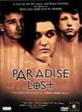
3 | May 11 | Labeling Theory: Is it Everywhere? | Modify (2005)  Introducing viewers to people who've explored branding, piercing, tattooing, tongue splitting and every body modification imaginable, this striking documentary plumbs the thoughts of artists and their human canvases to reveal how and why they've gone to such extremes to express themselves. Jason Gary and Greg Jacobson's groundbreaking film also features an original soundtrack featuring more than 20 new musical artists.
4 | May 12 | The Normality of Deviance | Goth & Vampires: A Varity  Vampires: Fox News 8  Goth Murder Madness  Satan in the Suburbs  If I Only Were a Goth  I’m so Goth  When you’re Evil | 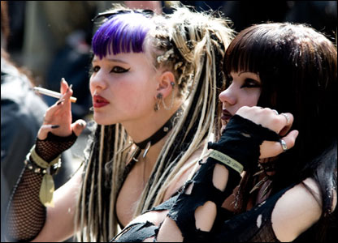

5 | May 16 | Moral Panics | Taggers (2005)  Frontpage: overview of taggers in America  Bomb It (2007)  Graffiti isn't simple vandalism; it's an artistic expression employed around the world. Filmmaker Jon Reiss travels five continents to reveal graffiti's history, cultural impact and social relevance. Noted artists share their stories, bringing this vital form of expression out of the shadows. It's on freeway overpasses, buildings and billboards. Now, see the real meaning of the world's graffiti. |  | Week 1 Film Questions due
6 | May 17 | Levels of Involvement | Gangland: Basic Training (2007)  This documentary tells of gang members entering our military and serving, usually, one tour, then getting out and taking their military training back to their gangs. In many cases these gang members, due to their military training, have more specialized skills than the police officers who have the misfortune of going up against them.  Gangland: Root of All Evil (2007)  Gangland takes a look at the Drugs and Prostitution rackets run by MS-13. | 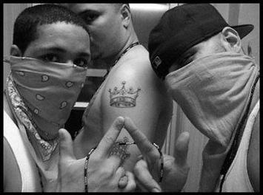
7 | May 18 | Art Imitates Life: Violence and The Music of Metal and Rap | History of Metal: PMRC clip  A little clip about the PMRC US Senate Hearings in the 1980s  GLOBAL METAL (2008)  In GLOBAL METAL, directors Scot McFadyen and Sam Dunn set out to discover how the West's most maligned musical genre - heavy metal - has impacted the world's cultures beyond Europe and North America. The film follows metal fan and anthropologist Sam Dunn on a whirlwind journey through Asia, South America and the Middle East as he explores the underbelly of the world's emerging extreme music scenes; from Indonesian death metal to Chinese black metal to Iranian thrash metal. GLOBAL METAL reveals a worldwide community of metalheads who aren't just absorbing metal from the West - they're transforming it - creating a new form of cultural expression in societies dominated by conflict, corruption and mass-consumerism.
8 | May 19 | Black Metallers and Gangster Rappers: Anti-Cultures Make Strange Bedfellows | Norwegian Black Metal Documentary (2007)  An overview of the early days!  Black Metal: Unholy Music (2007)  Independent filmmaker Bill Zebub explores the controversial yet popular subject of extreme heavy metal music with a raw, no-frills approach in this 2007 documentary, which includes interviews with musicians who helped spawn and shape the subgenre. Weighing in are members of Darkthrone, Immortal, Gloomy Grim, Enslaved, Mortiis, Dark Funeral, King Diamond and first wave innovators Celtic Frost and Venom.

9 | May 23 | Experience: The Music Connection  International Music | A&E: Investigative Reports The New Skinheads (2008)  More than 20 years ago, the first skinheads appeared in England. Violent youths with shaved heads, they intimidated any in their path. But for all their brutality and viciousness, they were too extreme to be a real threat to society, and many experts today feel that the movement is dead. See why that optimistic view may be far from the truth in this disturbing program.  HBO: Skinhead USA (1996)  This documentary takes you inside to an actual neo-Nazi Skinhead organization for a extended look at the methods and mentality that fuel the White Power youth movement in America. Focusing on the Alabama-based Aryan National Front and its leader, Bill Riccio, this special features behind-the-scenes footage of group members in their rural commune, at a series of White Power rallies, at a cross-burning Skinhead/KKK "Unification Rally," and on the brink of extinction following the arrest of Riccio.  Gang Nation: Neo-Nazi (Russia) (2009)  Examination of underground Russian Neo-Nazi groups in training.  INSIDE: American Nazis (2008)  'American Nazis' goes inside the growing trend of hate in America. Neo-Nazi groups in the U.S. are made up of many factions, but they share a common ideology that includes veneration of Hitler, hatred of Jews, and white supremacy. We go inside three extreme groups - Aryan Nations, White Revolution, and the Nationalist Socialist Movement - to discover how they exploit anti-immigration sentiment for their own agenda, and how their violent rhetoric has led to hate crimes against Jews and Latinos. | 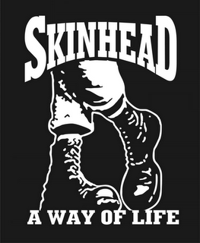 | Week 2 Film Questions due

10 | May 24 | Theoretical Aspects | Punk: Attitude (2005)  A documentary on the music, performers, attitude and distinctive look that made up punk rock. | 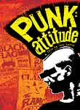
11 | May 25 | A Framework for Understanding | Gang Nation: Hooligans (Poland) (2008)  In Poland, Kemp confronts the violent Neo-Nazi football hooligans who have become one of the most feared gangs in Europe. These groups are comprised of primarily young men with few prospects in life. They use violence as a means of escape and Kemp experiences a brutal face-off with police riot squads. | 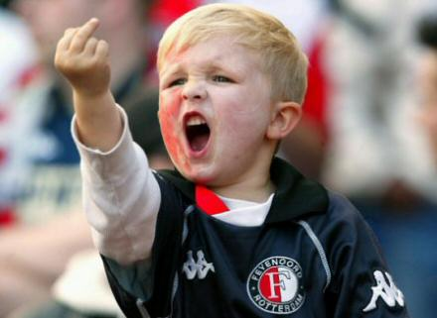
12 | May 26 | Student Lectures

13 | May 31 | Student Lectures |  |  | Week 3 Film Questions due  All Portfolios are due!
14 | June 1 | Student Lectures
15 | June 2 | Final Exam | * Cummulative Exam covering everything from the course!

Film Analysis Questions

We will watch various films during this term dealing with our overall topic of international juvenile subcultures. The films have been carefully selected for this course and are very unique. After viewing each film, students will be required to write a 2-page paper addressing specific questions that are listed below. These will be due at the end of each of the first three (3) weeks. (Most of these documentaries/films/clips are very graphic, violent, and involve very harsh language ~ this is for educational purposes only, no offense to anyone is intended)

Your typed submissions for each film must following the following format:

Name:

Title of Film:

Questions

- What subculture(s) was the film examining?
- When and where was the film made?
- How were the group(s) that were portrayed?
- How was the police/government response portrayed?
- How was the societal response depicted?
- What do you think makes the lifestyle(s) presented so attractive to some young people?
- What did you find most interesting in this film?

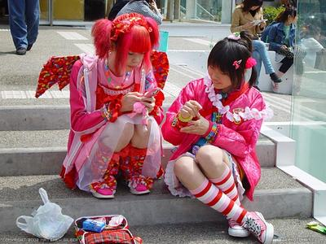 International Subculture Portfolio

Over the course of the term, each student will be responsible for collecting and summarizing information about one subculture of their choice. Each student will be expected to analyze the information collected in a criminological manner, and demonstrate that in their student lectures.

During the first day of class, each student will be assigned a particular youth subculture to study (e.g. punk, riot grrrl, Goth, hardcore, hip-hop, skateboarding, graffiti, gaming). You will be responsible for collecting and analyzing information throughout the world about your subculture as it pertains to theories and concepts being covered in class.

To do this, you will first need to identify Subcultural objects for analysis. These may include (i) a definition of the subculture you are studying, (ii) a song and/or music lyrics, (iii) a research article (historical, sociological, cultural, etc.), (iv) an Internet discussion forum, (v) an event at a local hangout, bar, or club, (vi) a zine, blog, or other publication, (vii) cartoon, album cover, or other art, (viii) journalistic account of a Subcultural event, (viiii) a pop culture item (e.g. clip from television, magazine article), or (x) a video (e.g. YouTube) or documentary.

You are essentially expected to collect everything you can about the youth subculture and reactions to it throughout the world you have been assigned: history of the group, extent of its membership, conflicts with society, why are juveniles interested in it, and what are people doing with or about this group around the world.

International Portfolio Format

All of the following should be placed in an Acco File Folder (Example will be shown in class) and separated properly by dividers:
- Cover page (Student Name/Name of Group being studied)
- History of Group
- Statistics/Extent of membership
- News Articles
- Reactions by International Society
- Reactions by International Police
- Journal Articles
- National Implications (US)
- International Implications (All Others)
- Photos
- List of All References

This format can be changed to meet the needs of individual research projects, BUT you need to keep it a GLOBAL PERSPECTIVE!

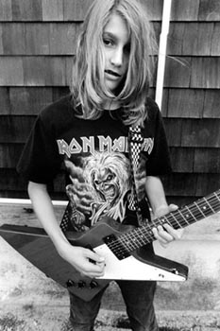 International Subculture Presentation

Each student will be given the opportunity to present all of their findings to the rest of the class. The format for these presentations are totally up to the individual student, but should be comprehensive and last at least 20 – 30 minutes or so.

NOTE: Graduate Students will also be required to give their Theorist Presentation as described below:

Graduate students are to pick ONE of the below Subculture Theorists and give a brief overview of their major ideas, publication, and contributions to the study of youth subcultures:

Paul Hodkinson Stanley Cohen Jeffrey Victor Greg Fine Howard S. Becker
Dick Hebdige Andy Bennett Lauraine Leblanc David Muggleton Sarah Thornton

Crews’ Nine Academic Rules of the Earth

- Classroom Conduct:

- As a general rule, I, 1) show up for class, 2) arrive on time, 3) am semi-prepared, 4) sober/conscious, and 5) interested in the topic of the day ~ I expect the same of you!!!!

- All cell phones must be turned off and put away (out of view) at the commencement of class, with the exception of emergency service personnel. Cell phones are disruptive not only to me, but your fellow students, so please be courteous. You will receive only one warning if your cell phone goes off in class, or if I catch you playing with it during class.

- You may NOT eat during class. This means food of any kind (chips, sandwiches, candy, etc.). However, drinks are permitted (non-alcoholic of course). Also, you should not be working on anything not related to this class once class commences (this includes reading, copying other’s notes, knitting, playing games on your cell phone, etc.).

- Do NOT leave the classroom once class has started, unless it is an absolute emergency or you have notified me before class that you will be leaving. You should use the restroom, get a drink of water, and make a phone call, etc. before class starts.

- Do NOT bring weapons into the class. If you are a law enforcement officer and required to be armed, please let me know.

- You are not allowed to smoke within the building, and I will not permit smokeless tobacco in my classroom.

- Student Participation:

- Don’t hesitate to ask questions, the dumbest question is the one not asked! If you ask a question I can’t answer, I’ll find out the answer and get back to you. Please remember that as a teacher, I am merely your guide through the field, I am not the field itself! (Although, my wife would say I think I AM!).

- During discussions please respect different viewpoints; there is always more than one side. Treat others’ views as you would want your own to be treated, with an open mind. Personal attacks on others will not be tolerated!

- I like to run my classes as an open forum where we can all learn from each other, so I encourage intelligent discussions, questions, and comments, but at the same time we have to remember that we are at a university setting and must act accordingly.

- Professor and Student Responsibilities:

- I realize that every now and then, unexpected and difficult situations arise. However, when you enrolled in this class, you made a commitment to me, to yourself, and to your fellow classmates. I expect you to fulfill that commitment to the best of your ability. If you are unable to fulfill my expectation, I am really not interested in your reasons. That does not mean that I am cold and heartless, just that I have established standards for my classes that I know work from many years of experience.

- Experience has shown that it is impossible for students who miss class to pass this course. However, the reverse is also true. Those students who do not miss class and who submit work on time generally score quite high. This course is one that builds from meeting to meeting and one concept to another and requires that previously covered material be understood before one can reasonably expect to move to the next. Attendance is therefore expected. Attendance will be taken at various points during the term. Students who are not present when attendance is taken will not be credited with attending class on that day.

- Make up Policy:

- There will be no excused absences on exam days and no assignments can be made up! Any paper/project/in class work not turned in/completed on the date and time specified in the syllabus will receive a zero. Only documented medical emergencies will be considered as reasonable excuses for allowing a paper/project to be turned in late, an exam made up, or a presentation delayed, all others will be given a zero. Due dates are set in the course schedule for turning in projects and for giving presentations ~ due to the nature of these requirements, they cannot be made up.

- Extra Credit:

- At various points during the semester the instructor MAY offer opportunities for students to gain extra credit points. These are generally onetime events which reward students who take advantage of opportunities to attend out of class presentations or complete assignments in class. These can NEVER be made up; there is ample opportunity in this class for each student to obtain more than enough points to achieve an “A” ~ therefore, opportunities are a PRIVILAGE not a RIGHT and at the instructor’s discretion.

- Office Hours:

- I encourage all my students to make use of my office hours, they are there for you. If you can’t make it at the scheduled times, let me know and we can arrange to meet at another time. However, this invitation is only for those students who come to class on a regular basis and put forth a genuine effort to learn. Also, please keep in mind that I have a life too (albeit, dark and demented), and while my office hours are mandatory, my other time is not, so my flexibility can only extend so far.

- Course Materials:

- A syllabus with a detailed schedule is provided for each course, the instructor will do their utmost to follow the syllabus and it is expected that the student will as well. All due dates are listed and will be enforced (do not ask for them to be altered for any reason). Most lectures will be on PowerPoint. These presentations will generally occur one time in the course while the material is being discussed in class. I may post online lecture shells for you to use.)

- Cheating, Plagiarism, and General Academic Dishonesty:

- Don’t cheat or plagiarize! Academic dishonesty is something I take very seriously and will not tolerate. Anyone caught cheating or plagiarizing will automatically receive a failing grade for the course and will be referred to the dean for appropriate disciplinary action. Plagiarism from the internet has become a very serious problem and professors now have access to various software programs to identify this behavior, so at this point in your academic career, don’t risk it!

- University Policies/Instructor Prerogative:

- Any items or events not covered in this syllabus will be handled according to established university policies and/or instructor’s prerogative.
- University ADA Statement: The American with Disabilities Act has established a robust set of Federal Regulations that ensure employees and students receive fair and reasonable accommodations as they work and study. It has been my experience that students with disabilities exert considerable effort to achieve their educational goals. Moreover, I have found the accommodations to represent efforts in good pedagogy rather than special treatment for the student. As such, I hope each of you will work collaboratively with the Office of Disabled Student Services as the need arises.

Brief Faculty Member Biographical Sketch

Dr. Gordon A. Crews is currently a Professor in the Department of Criminal Justice at Marshall University. Prior to this position, he served as Associate Professor in the Department of Criminal Justice at Washburn University in Topeka, Kansas. Since 1990, Dr. Crews has served as a faculty member and/or academic administrator at Cameron University (OK), Roger Williams University (RI), Jacksonville State University (AL), Valdosta State University (GA), and the University of South Carolina Beaufort (SC).

He earned a Ph.D. in Education/Criminal Justice, a Graduate Certificate in Alcohol & Drug Studies, a Bachelor of Science in Criminal Justice, and Masters of Criminal Justice, from the University of South Carolina (SC). He served as Executive Counselor for the Juvenile Justice Section of the Academy of Criminal Justice Sciences and as former President and member of the Board of Directors for the Southern Criminal Justice Association.

Prior to teaching, Dr. Crews worked in law enforcement as a bloodhound officer & trainer, field-training officer, and criminal investigator; in corrections as a training and accreditation manager; and in insurance fraud as an investigator. His publications include journal articles dealing with school violence, Occult/Satanic involvement and youth, and various law enforcement and correctional issues.

His books include Faces of Violence in America (1996), published by Simon & Schuster; The Evolution of School Disturbance in America: Colonial Times to Modern Day (1997), published by Praeger; A History of Correctional Violence: An Examination of Reported Causes of Riots and Disturbances (1998), published by the American Correctional Association; Chasing Shadows: Confronting Juvenile Violence in America (2001), published by Prentice Hall; Living in Prison: A History of the Correctional System with an Insider’s View (2004), published by Greenwood Publishers; and, In the Margins: Special Populations and American Justice (2008), published by Prentice Hall. His most recent book is entitled, Juvenile Delinquency and Violence: Examining International Police and Societal Response (2009), published by CRC/Taylor and Francis. Dr. Crews' current research interests focus on an international comparison of police and societal response to individuals involved in alternative belief practices (e.g., Satanism, Wicca, Goth, etc.).

Since 2000, he has conducted extensive field research in these areas across the United States, United Kingdom, Middle East, Netherlands, Central Europe, Scandinavia, Turkey, Ghana, and most recently in Central and Eastern Europe (Greece, Macedonia, Bulgaria, Romania, Hungry, Slovakia, Austria, Czech Republic, Slovenia, Serbia, and Croatia).

Group Descriptions (A few to consider!)

Subculture
Goth/Vampires

Definition: The Goth subculture is a contemporary subculture found in many countries. It began in the United Kingdom during the early 1980s in the gothic rock scene, an offshoot of the post-punk genre. The Goth subculture has survived much longer than others of the same era, and has continued to diversify. Its imagery and cultural proclivities indicate influences from nineteenth century Gothic literature along with horror movies and to a lesser extent the BDSM culture. The Goth subculture has associated tastes in music, aesthetics, and fashion, whether or not all individuals who share those tastes are in fact members of the Goth subculture. Gothic music encompasses a number of different styles. Common to all is a tendency towards a lugubrious, mystical sound and outlook. Styles of dress within the subculture range from death rock, punk, androgynous, Victorian, some Renaissance and Medieval style attire, or combinations of the above, most often with black attire, makeup and hair.

Metallers/HeadBangers
Definition: The term "headbanger" was coined during Led Zeppelin's first US tour in 1968. During a show at the Boston Tea Party, audience members in the first row were banging their heads against the stage in rhythm with the music. Lemmy from Motörhead, however, said in an interview on the documentary The Decline of Western Civilization II: The Metal Years that the term "Headbanger" may have originated in the band's name, as in "Motorheadbanger".

Punks
Definition: The punk subculture is a youth movement based around punk rock. Punk first emerged from the rock music scene in the United States and the United Kingdom in the mid-1970s. Since then, the punk movement has spread around the world and developed into a number of different forms with much regional variation. Punk culture encompasses certain styles of music, ideology, fashion, visual art, dance, literature, and film. Punks tend to live a certain lifestyle and share a sense of community with one another. The punk scene is composed of an assortment of smaller subcultures, such as Oi! and hardcore punk. These subcultures distinguish themselves from one another through unique variations on punk culture. Several of these factions have developed out of punk to become youth movements in their own right, including straight edge, Goth and psychobilly. Punk has had a tumultuous relationship with both popular culture and other subcultures.

Skinheads
Definition: A skinhead is a member of a subculture that originated among working class youths in the United Kingdom in the 1960s, and then spread to other parts of the world. Named for their close-cropped or shaven heads, the first skinheads were greatly influenced by West Indian (specifically Jamaican) rude boys and British mods, in terms of fashion, music and lifestyle. Originally, the skinhead subculture was primarily based on those elements, not politics or race. Since then, however, attitudes toward race and politics have become factors in which some skinheads align themselves. The political spectrum within the skinhead scene ranges from the far right to the far left, although many skinheads are apolitical. Fashion-wise, skinheads range from a clean-cut 1960s mod-influenced style to less-strict punk- and hardcore-influenced styles.

Traditional Street Gangs

Definition: A gang is a group of people who, through the organization, formation, and establishment of an assemblage, share a common identity. In current usage it typically denotes a criminal organization or else a criminal affiliation. In early usage, the word gang referred to a group of workmen. In the United Kingdom the word is still often used in this sense, but it later underwent pejoration. The word gang often carries a negative connotation; however, within a gang which defines itself in opposition to mainstream norms, members may adopt the phrase as a statement of identity or defiance.
The term gangster (or mobster) refers to a criminal who is a member of a crime organization, such as a gang. The terms are widely used in reference to members of gangs associated with American prohibition and the American offshoot of the Italian Mafia, such as the Chicago Outfit or the Five Families. The related word "mobster" is a term derived from Latin and Aramaic. The word mobi means large gathering in Aramaic, and similarly, mob in Latin means crowd.
Gang is from the past participle of Old English gan "to go". It is cognate with Old Norse gangr "a group of men", and it is in this sense that the word is used today, rather than the older meaning.

Hooligans/Gangs

Definition: Hooliganism refers to unruly and destructive behavior. Such behavior is commonly associated with sports fans, particularly supporters of professional football and university sports. In some countries, the hooligan elements of a group of supporters are known as Category C. The term can also apply to general rowdy behavior and vandalism, often under the influence of alcohol or drugs.

Hippies/Drug Culture

Definition: The hippie subculture was originally a youth movement that began in the United States during the mid-1960s and spread around the world. The word hippie derives from hipster, and was initially used to describe people who created their own communities, listened to psychedelic rock, embraced the sexual revolution, and used drugs such as cannabis and LSD to explore alternative states of consciousness.

Gamer
Definition: Historically, the term "gamer" usually referred to someone who played role-playing games and war games. More recently, the term has grown to include players of video games. While the term nominally includes those who do not necessarily consider themselves to be gamers (i.e., casual gamers), it is commonly used to identify those who spend much of their leisure time playing or learning about games. There are many gamer communities around the world. Many of these take the form of web rings, discussion forums and other virtual communities, as well as college or university social clubs. Stores specializing in games often serve as a meeting place to organize groups of players. Prior to the emergence of the Internet, many play-by-mail games developed communities resembling those surrounding today's online games

Emo
Definition: a style of rock music typically characterized by melodic musicianship and expressive, often confessional lyrics. It originated in the mid-1980s hardcore punk movement of Washington, D.C., where it was known as "emotional hardcore" or "emocore" and pioneered by bands such as Rites of Spring and Embrace. As the style was echoed by contemporary American punk rock bands, its sound and meaning shifted and changed, blending with pop punk and indie rock and encapsulated in the early 1990s by groups such as Jawbreaker and Sunny Day Real Estate. By the mid 1990s numerous emo acts emerged from the Midwestern and Central United States, and several independent record labels began to specialize in the style.
Emo broke into mainstream culture in the early 2000s with the platinum-selling success of Jimmy Eat World and Dashboard Confessional and the emergence of the subgenre "screamo". In recent years the term "emo" has been applied by critics and journalists to a variety of artists, including multiplatinum acts and groups with disparate styles and sounds. In addition to music, "emo" is often used more generally to signify a particular relationship between fans and artists, and to describe related aspects of fashion, culture, and behavior

Juggalo or Juggalette (the latter being feminine)
Definition: a name given to fans of Insane Clown Posse or any other Psychopathic Records hip hop group. Juggalos have developed their own idioms, slang, and characteristics. The term originated during a 1994 live performance by Insane Clown Posse. During the song "The Juggla", Joseph Bruce addressed the audience as Juggalos, and the positive response resulted in Bruce and Joseph Utsler using the word thereafter to refer to themselves and their friends, family, and fans, including other Psychopathic Records artists. Juggalos have compared themselves to a family. Common characteristics include drinking the inexpensive soft drink Faygo and wearing face paint. They view the lyrics of Psychopathic Records artists (which are often violent in nature) as a catharsis for aggression. Several well-known figures have identified themselves as Juggalos. These include actor Kane Hodder, professional wrestlers Kazushige Nosawa, Vampiro, and Colt Cabana, and rappers Chuck D, Coolio, Kung Fu Vampire, MURS, and Vanilla Ice. According to Utsler, "[Juggalos come] from all walks of life -- from poverty, from rich, from all religions, all colors. [...] It doesn't matter if you're born with a silver spoon in your mouth, or a crack rock in your mouth."

Taggers/Graffiti Artists
Definition: A stylized signature, normally done in one color. The simplest and most prevalent type of graffiti, a tag is often done in a color that contrasts sharply with its background. Tag can also be used as a verb meaning "to sign". Writers often tag on or beside their pieces, following the practice of traditional artists who sign their artwork. A less common type of tag is a "dust tag", done in dust by writers to practice. The verb tagging has even become a popular verb today in other types of occasions that are non-graffiti-related. Tagging first appeared in Philadelphia, with spray-painted messages of "Bobby Beck In '59" on freeways surrounding the city. The first "king" was also crowned in Philly: Cornbread (graffiti), a student who began marking his nickname around the city to attract the attentions of a girl. In New York City, TAKI 183 inspired a newspaper article about his exploits, leading to an explosion of tagging in the early seventies.

Body modification/freaks
Definition: Body modification (or body alteration) is the deliberate altering of the human body for aesthetic or non-medical purpose, such as sexual enhancement, a rite of passage, denoting affiliation, trust and loyalty, religious reasons, shock value, and self-expression. It can range from the socially acceptable decoration (e.g., pierced ears in many societies) to the religiously mandated (e.g., circumcision in a number of cultures), and everywhere in between. Body art is the modification of any part of the human body for spiritual, religious, artistic or aesthetic reasons.
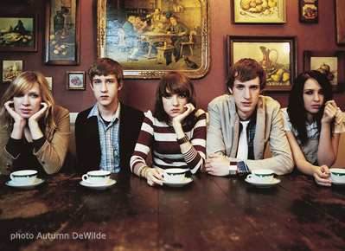 Youth Subculture

YOUTH SUBCULTURE: AN OVERVIEW

A youth subculture is a youth-based subculture with distinct styles, behaviors and interests. According to subculture theorists such as Dick Hebdige, members of a subculture often signal their membership by making distinctive and symbolic tangible choices in, for example, clothing styles, hairstyles and footwear. However, intangible elements, such as common interests, dialects and slang, music genres and gathering places can also be an important factor. Youth subcultures offer participants an identity outside of that ascribed by social institutions such as family, work, home and school.

Social class, gender and ethnicity can be important in relation to youth subcultures. Youth subcultures can be defined as meaning systems, modes of expression or lifestyles developed by groups in subordinate structural positions in response to dominant systems — and which reflect their attempt to solve structural contradictions rising from the wider societal context. The study of subcultures often consists of the study of the symbolism attached to clothing, music, and other visible affections by members of the subculture and also the ways in which these same symbols are interpreted by members of the dominant culture.

The term scene can refer to an exclusive subculture or faction. Scenes are distinguished from the broad culture through either fashion; identification with specific (sometimes obscure or experimental) musical genres or political perspectives; and a strong in-group or tribal mentality. The term can also be used to depict specific subsets of a subculture, habitually geographical, such as the Detroit drum and bass scene or the London Goth scene. A quantity of scenes tend to be volatile, imprudent to trends and changes, with some participants acting elitist towards those considered to be less fashionable, or oppositional to the general culture although others do endow with mutual support in marginalized groups. In-group behavior can sometimes elicit external opposition. Subcultures that show a systematic hostility to the dominant culture are sometimes described as countercultures.

FEATURES OF YOUTH SUBCULTURES

Youth subcultures are often defined or distinguishable by elements such as fashion, beliefs, slang, dialects, behaviors or interests. Vehicles—such as cars, motorcycles, scooters, skateboards, surf boards—have played central roles in certain youth subcultures. In the United Kingdom in the 1960s, mods were associated with scooters while rockers were associated with motorcycles. Many youth subcultures are associated with specific music genres, and in some cases music has been the primary characteristic of the group, such as with punk rockers, ravers, Metalheads, Goths, hip hoppers, emo and indie.

THEORIES ABOUT YOUTH SUBCULTURE

Early studies in youth culture were mainly produced by functionalist sociologists, and focus on youth as a single form of culture. In explaining the development of the culture, they utilized the concept of anomie. Talcott Parsons argued that as we move from the family and corresponding values to another sphere with differing values, (e.g. the workplace) we would experience an "anomie situation."] The generalizations involved in this theory ignore the existence of subcultures. Marxist theories account for some diversity, because they focus on classes and class-fractions rather than youth as a whole. Stuart Hall and Tony Jefferson (1993) describe youth subcultures as symbolic or ritualistic attempts to resist the power of bourgeois hegemony by consciously adopting behavior that appears threatening to the establishment. Conversely, Marxists of the Frankfurt School of social studies argue that youth culture is inherently consumerist and integral to the divide-and-rule strategy of capitalism. They argue that it creates generation gaps and pits groups of youths against each other (e.g. mods and rockers or Skinheads vs. Punks or hippies) — especially as youth culture is the dominant culture in the west.

Interactionist theorist Stan Cohen argues youth subcultures are not coherent social groupings that arise spontaneously as a reaction to social forces, but that mass media labeling results in the creation of youth subcultures by imposing an ideological framework in which people can locate their behavior. Post-structuralist theories of subculture utilize many of the ideas from these other theories, including hegemony and the role of the media. Dick Hebdige describes subcultures as a reaction of subordinated groups that challenge the hegemony of the dominant culture. This theory accounts for factors such as gender, ethnicity and age. Youth can be seen as a subordinate group in relation to the dominant, adult society.

In Historical theory, Steven Mintz claims that until about 1950, youth subculture as such did not exist. Children aspired to (or were pulled into) adulthood as fast as their physical development allowed. Marcel Danesi argues that since then, the media, advertisers and others have made youth the dominant culture of Western societies, to the point that many people retain what others consider to be immature attitudes far into adulthood. This is further supported by the likes of P. Lewis, who claims that youth culture did not develop until the 1950s and the development in 'rock and roll'. However other historians have claimed that youth culture may have developed earlier, particularly in the inter-war period. Indeed there are examples of new youth sub-cultures emerging throughout this time, such as the 'flapper'.

Presentation Evaluation Sheet
Intersession 2011

CJ 483/583: Special Topics in Criminal Justice

Name(s): _____________________________________________ Topic(s): _________________________________________________

Criteria for grading:

- Quality of Analysis (50): 0 10 20 45 50
(Does the presenter(s) accurately examine the topic and logically structure the parts of the presentation?)

- Effective Research Design (50): 0 10 20 45 50
(Is the design effective and appropriate for the type of presentation?)

- Intellectually stimulating (50): 0 10 20 45 50
(Does the presentation provide thought-provoking information?)

- Use of Visuals (50): 0 10 20 45 50
(Does the presenter(s) use at least 5 visuals in the presentation, PowerPoint counts as 3 visuals)

Additional Comments:
____________________________________________________________________________________________________________________________________________________________

Total Points: ________ .

