Calculus I -- Fall 2017
MTH 229 - Calculus with Analytic Geometry I (CT). An introduction to analytic geometry. Limits, derivatives, and integrals of the elementary functions of one variable, including the transcendental functions. (PR: MTH ACT of 27 or above, or MTH 130 and 122, or MTH 127 and 122, or MTH 132) This course meets a Core I/Critical Thinking requirement.
- Time and Place: 5:00 pm - 5:50 pm MW and 5:00 pm - 6:15 pm TR at 518 Smith Hall.
- Instructor: Peter Saveliev (call me Peter).
- Office: Smith Hall 713.
- Office Hours: MW 3:00 - 5:00, or by appointment.
- Office Phone: x4639.
- E-mail: saveliev@marshall.edu.
- Class Web-Page: math01.com.
- Prerequisites: fluency with algebra, good understanding of functions.
- Text: Calculus by Stewart and the lecture notes.
- Goals: good understanding of limits, the derivative and the integral, fluent differentiation.
- Computer Restrictions: graphic calculator TI-83 or TI-83+.
- Activities: the student will practice each outcome via the homework given in the textbook and online.
- Evaluation: the student achievement of each outcome will be assessed via:
  - in-class quizzes: taken from the textbook's exercise sets;
  - online quizzes: based on the course material, provided by Webwork, http://webwork.marshall.edu/webwork2/F17-Math-229-Saveliev/;
  - in-class tests: based on the textbook's exercises;
  - projects: written applications of calculus in science and engineering.
- Grade Breakdown:
  - participation: 5%,
  - quizzes: 25%,
  - project: 20%,
  - midterm: 20%,
  - final exam: 30%,
i.e., the total score is the following weighted average of the five scores:
TOTAL =.05×P+.25×Q+.20×P+.20×M+.30×F.

Course policy
SAVE A COPY!
Note: Some parts of this policy may not apply to your specific course. Consult your syllabus.
1. Homework. You should start with the textbook and lectures. Make sure you understand all new concepts and ideas. Contemplate... Not until you feel comfortable about the material should you turn to the actual assignment. This assignment is a test. It tests your knowledge of a small part of what you need to know.
2. Online Quizzes. They are provided via Webwork or Hawkes Learning. This assignment is a test. It tests your knowledge of a small part of what you need to know. Please anticipate potential technical problems as the deadlines are firm.
3. In-Class Quizzes. They will be 5-10 minutes long, open book.
4. Written Assignments. You can discuss them with other students but you can't copy. Nor should you use the internet to search for answers. Unless a special arrangement has been made, the submission should be on paper. Please staple. Everything should be written legibly with generous margins and room between the lines. Always state the problem being solved at the top of the page. Advanced courses: assignments submitted in TeX may receive extra credit of one point provided the TeX code or the PDF is emailed to me -- in addition to the paper -- as it might be posted online.
5. Exams. The midterm will be based on the material covered since the beginning. The final exam will be comprehensive and cumulative. The material since the last midterm will receive more emphasis.
6. Writing. You should write in complete sentences, including all algebra:
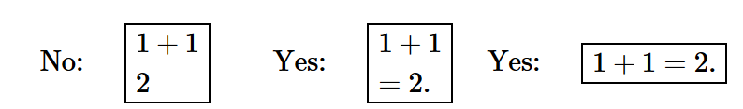
You should justify all your steps and conclusions, including all algebra:
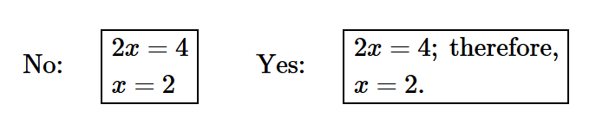
Advanced courses: examine also Student's guide to proof writing.
7. Calculators. You shouldn't need them but they are allowed in class. Your syllabus lists computer restrictions not requirements. Any equipment more complex than what's indicated is not allowed. This applies to quizzes, tests, and the homework assignments. You can certainly use them to test your answers. Whatever you submit, it should be able to stand on its own -- without references to a calculator. For example, providing the graph of a function with no explanation where it has come from is inadequate. There will be no instruction on how to use calculators.
8. Grades. The grade for the class will be based entirely on your performance. Individual problems in homework, quizzes, and exams will be graded with a score between 0 and 10. These scores are converted to decimals and then combined according to the formula provided in your syllabus. The total score determines your letter grade according to the scale below (no curving):
F[0,.60)D[.60,.70)C[.70,.80)B[.80,.90)A[.90,1.00]
It is each student's responsibility to carry out these computations on a regular basis. You may use this spreadsheet.
The zero score will be given for problems not submitted or not attempted and I will give partial credit if you've made meaningful progress in the problem. The final exam scores won't be released until the grades are posted by the university.
9. Missed Assignments and Exams. There will be no late homework accepted or make-up tests given. However, you will receive credit if
- you have a valid reason for absence: illness, death in the family, approved institutional activity, etc. (see the university excused absence policy); and
- you submit an explanation in the form of an e-mail (you may be asked to provide a note from a relevant authority).
In that case, the missed score is assigned based on your other scores: next homework/quiz, next test, or the final exam. If the final is missed, the grade for the class will not be based on the rest of the grades but entirely on my assessment of the student's achieved level of mastery. One weekly assignment (quiz or homework) may be dropped.
10. Attendance. You should make all efforts to be there and on time. Expect a high degree of "continuity" from one period to the next, so that if you miss a class (for any reason), next time you may feel lost unless you work out the lesson at home. If you have missed a class without a valid excuse, you are not allowed to attend the next class without permission.
11. In Class. During the lectures, feel free to interrupt me at any time if you want to ask a question. You don't have to raise your hand. In fact, I expect you to participate in class work by asking questions, answering questions (keep the pen handy), pointing out mistakes, making suggestions, comments, etc. Consider taking rudimentary notes: main theorems and formulas, and try to reproduce some pictures.
Please refrain from any activities that may lead to distraction, which include but aren't limited to:
- coming late, leaving early;
- using cell phones, laptops, etc. (you should only touch your phone to turn it off);
- eating, drinking, and so on.
12. Office Hours. A few hours every a week are set aside for meeting students one-on-one, in my office. You can come at any time during these hours. You cannot ask for help with homework problems. Consider also the tutoring services provided by the department and the university.
13. Academic Integrity. Cheating will result in the zero grade for the assignment.

