Marshall University

Physics Department
Course Title/Number | PHY 213
Semester/Year | Spring 2015
Location | SCIENCE 277
Instructor | John Winfrey
Office | SCIENCE 255
Phone | 304-696-2755
E-Mail | winfreyj@marshall.edu Please put PHY 213 in the subject line of emails
Office/Hours | MTuWF 10:00-10:45; R 1:00-1:45
University Policies  Instructor Policies | By enrolling in this course, you agree to the University Policies listed below. Please read the full text of each policy by going to www.marshall.edu/academic-affairs and clicking on “Marshall University Policies.” Or, you can access the policies directly by going to http://www.marshall.edu/academic-affairs/?page_id=802  Topics you are responsible for understanding: Academic Dishonesty/ Excused Absence Policy for Undergraduates/ Computing Services Acceptable Use/ Inclement Weather/ Dead Week/ Students with Disabilities/ Academic Forgiveness/ Academic Probation and Suspension/ Academic Rights and Responsibilities of Students/ Affirmative Action/ Sexual Harassment.  Inclement Weather Policy: This course will comply with Marshall University’s rules for inclement weather. Please reference the Marshall University website, if questionable weather conditions exist, to determine if class will be meeting.  General Emergencies: http://www.marshall.edu/emergency/  MU Alert Sign Up: http://www.marshall.edu/emergency/mualert/  Midcourse corrections: Information in this syllabus was, to the best knowledge of the instructor, considered correct and complete when distributed at the beginning of the term. The instructor, however, reserves the right, acting within policies and procedures of Marshall, to make changes in the course content and/or instructional techniques during the term without notice or obligation.  Student Conduct: Student rights and responsibilities are outlined in the Marshall catalog, page 34. Especially, the infractions and violations listed under "Conduct, Rights and Regulations" will be enforced in this class. Students who disrupt class may be removed from class (failing all of the activities for the day) on a daily basis, as warranted, by the instructor. Continuing behavior problems will result in an instructor drop of the offending student.  Cell Phone/Ipad/anything electronic: Telephones may be set to vibrate during regular class times. If an emergency call comes through, please leave the class before you answer it. Otherwise, just enjoy the vibration. If during an EXAM, ANY of these devices are “on” or “visible”, they belong to me and you get a zero (0) on that exam.

Course Description: From Catalog
A course in basic principles of physics for physics, mathematics, and engineering majors. 4 hrs. lec.
Includes: Electricity & Magnetism, Circuits, Geometric & Wave Optics, and Atomic & Nuclear Physics.

Web Sites:

MUOnline: http://www.marshall.edu/muonline/

Use your MyMU UN & PW. Many, many essential resources here

Online Homework: http://www.weassign.net Course Key: marshall 7801 8228

The table below shows the following relationships: How each student learning outcomes will be practiced and assessed in the course.
Course Student Learning Outcomes | How students will practice each outcome in this Course | How student achievement of each outcome will be assessed in this Course
Students will | Solve physical problems involving Electricity & Magnetism, Circuits, Geometric & Wave Optics, and Atomic & Nuclear Physics ,all using the mathematical tools from algebra, trigonometry, solid geometry, calculus, and vectors. | Group Work, Homework, Quizzes, Examinations
Students will | State in words and in formulas functional relationships in physical science. Interpret equations found in reference books and identify limitations applying to those equations. Properly implement an equation found in a reference book (including the text book) to a physical problem of interest. | Group Work, Homework, Quizzes, Examinations
Students will | Apply physical principles to everyday life problems. | Examinations
Students will | Demonstrate the ability to work effectively as a team member. | Group Work

Required Texts, Additional Reading, and Other Materials

- University Physics with Modern Physics (13th Ed.), Young & Freedman.
- WEBASSIGN student access key

Grading Policy
Midterm Tests (3@30 points each) 90 pts
Final Examination 50 pts
Homework 20 pts
Individual Quizzes 10 pts
Group Work 10 pts
Diagnostic Tests (2 @ 3 points each) 6 pts

Total 186 pts

Notes:

Student Characteristics vs. Rewards: The "C" student will be able to mostly 'follow' problems worked in class and be able to 'reconstruct' the assigned homework problems; the "B" student will be able work these same problems with minor to major 'twists' in them; the "A" student will be able to work these problems in entirely new situations and to synthesize a combination of problem skills from various areas/topics/chapters within the course.

The "C" and "B" student will work all the homework Exercises assigned; the "A" student will work additional Problems within each chapter.

Examinations: You will be given three (3) within-term Exams. There will also be a mandatory comprehensive Final Examination. The material after Exam 3 is optional and mostly conceptual; we will get as far as we can, without whipping through the previous material at near light speed. The goal is to learn as deeply as possible. You can expect one of the Final Examination questions to be a 1-page essay on one of the optional topics we cover.

Do not expect simple plug 'n chug problems! Problems will synthesize concepts from several relevant chapters.

I believe in the value of returning your examinations to you so that you may further learn from what you have achieved (and not achieved). Therefore, I will require that on the day I return them, you must within the hour submit in writing on the front page of the examination any questions, rebuttals, or grading-dispute that you have about that examination.

I will not discuss this personally at that time, but take them home for consideration after a good dinner (when my understanding and mercy level is highest). I will post 'my' solution to exams on MUOnline a day after I pass back examinations

Under no circumstances will I reconsider any re-grading of your examination after this solution has been distributed and/or the examination has left the room for any reason.

Homework: At the end of this syllabus is a tentative class schedule and a list of assigned problems in your text. There is also a list of tutorials you should do first, and a set of Symbolic Problems you should do last. You will submit your answers to homework problems via WebAssign.

I suggest near the completion of each chapter you:

- Work the text problems out on paper the old fashioned way IN SYMBOLIC FORM.

- Enter your results in WebAssign. For those problems with constants given, it will adjust the given constants randomly so that you cannot just give numerical answers to your class mates. This process should be done by yourself, as it is the pre-test that will tell you if you are ready for THE TEST. As you enter results on MP, it will tell you if you are off-track immediately. You can use hints; you can put off entering this problem until you have had more time to think about it.

- Cramster & CHEGG doesn’t help, since you cannot use it on an exam. No pain, no gain. ALWAYS, feel free to stop by my office and discuss these problems. I may only give you the next hint, and send you back to struggle more.

I will post solutions to them on MUOnline after the chapter due date. I suggest that, if you omit doing these exercises, you will not pass the examinations. I also suggest that if you merely look at the solutions and say "yea, yea", you will not fare well in the course. Doing problems (producing solutions from scratch) and seeing solutions are very different skills. So bleed a lot before you look at the solutions.

Individual Quizzes: The information and skill burden of this class is intense! You will not survive if you do not pre-read the textbook material in a timely fashion, and if you are not prepared to engage in active problem-solving during class periods. I know how to do these problems. The point of the course is for you to learn to work them.

Therefore, nearly weekly (or with each new chapter), I will give (during the first 5 minutes of the class period) an individual quiz on content material of the chapter due to be discussed that day (follow your syllabus). This will not be a problem to solve, but a short-answer question to determine if you made an honest effort to pre-read the text materials assigned.

Group work: There will be in-class group-problems to solve to accomplish several tasks. I suggest you find your own groups to sit with, and then about mid-term change groups, so that you are exposed to the problem-solving skills of the entire class by the end of the term.

The purpose of these groups: This class is primarily aimed at producing critical-thinking skills, group membership/cooperation skills, and problem-solving skills. These group and problem-solving skills are taught primarily to prepare you for upper-division, and possibly graduate work, in a scientific area.

Watching me work problems is of limited utility (although many of you will disagree initially). You will learn problem-solving only by DOING problem-solving, and by BEING CRITIQUED by your group and by the instructor in a non-threatening setting.

The goals of these groups are to:

1) Prepare your group members for individual testing
2) Expose you to the full diversity of problem-solving skills that reside in your class members
3) Provide practice 'producing' and 'presenting' solutions to your classmates (the skill you need for tests)
4) Prepare you to go home and solve the homework problems as an individual.

Quiz & Group Work Grading:

So you get instant feedback as to how you are doing, these assignments will be graded on the following scale (0 – 10):

10 Perfect
9 Minor problems, annotated
8 More serious problems, annotated
0 You missed the point entirely. It is now your responsibility to re-work this activity,
because it is prime fodder for exams.

Other Course Expectations:

I expect the following routine student conduct:

- Read assigned textbook materials before the class in which they will be covered
- Do, to the best of your current ability, the homework and other assignments
- Attend all class and other sessions
- Be prepared to ask questions and participate in discussions; you will learn as much from each other as you do from the instructor.

TENTATIVE SCHEDULE
PHYS 213, Spring 2014

Week 1: J 12-16 Intro, CH 21 Electric Charge, Force, & Field

Week 2: J 21-23** CH 21cont.

Week 3: J 26-30 CH 22 Gauss’s Law (mostly conceptual)
CH 23 Electric Potential

Week 4: F 2-6 CH 24 (§1-4) Capacitance

Week 5: F 9 Exam #1
F 11-13** CH 25 Current, Resistance, EMF

Week 6: F 16-20 CH 26 DC Circuits

Week 7: F 23-27 CH 27 Magnetic Field & Force
CH 28 Sources of Magnetic Field

Week 8 M 2-6 CH 29 & 30 EM Induction & Inductance
CH 31 (§ 5, 6) AC Circuits

Week 9: M 9 Exam #2
M 11-13** CH 32 (§ 1-3) Electromagnetic Waves
CH 33 (§ 1-2, 4-5) Light

Week 10: M 23-27 CH 34 (§ 1-4) Geometric Optics

Week 11: M30- A3 CH 35 & 36 (§ 1-7) Wave Optics

Week 12 A 6 Exam #3

The remainder of the course will be mostly conceptual. These topics will be tested only on the Final Exam (one, one-page essay), as far as we get.

A 8-10** CH 37 (§ 1-4) Intro to Relativity

Week 13 A 13-17 CH 38 Wave-Particle Duality
CH 39 (§1-3)

Week 14 A 20-24 CH 40 (§1-2) QM, Atoms
CH 41 (§1-3) Atomic Structure

Week 15 A 27 – M 1 CH 43 The Nucleus

M 5 (Tuesday) Final Exam 10:15-12:15
** Two day week

Assigned Tutorials

These should be done FIRST.

You will go to the web page: http://www.wwnorton.com/college/physics/om/_content/_index/tutorials.shtml

and work through the tutorial assigned. Then answer a question on WebAssign from that content.

I CANNOT STRESS ENOUGH, THESE ARE ESSENTIAL TO UNDERSTAND CONCEPTUALLY THE MATERIAL AND TO PROBLEM-SOLVE.

Text Chapter Web Page Applet

21 The Electric Field
22 Electric Flux, Gauss’s Law,
23 Electrostatic Potential & Energy
24 Capacitance
26 DC Circuits
27 Charges & Currents in Magnetic Fields
29 Electromagnetic Induction
31 AC Circuits
34 Reflection, Refraction, and Optics
35 Interference & Diffraction

** The rest of these won’t be imbedded in WebAssign.
Do them for your own understanding of abstract concepts

The Theory of Relativity
Spectral Lines, Bohr’s Theory, & Quantum Mechanics
Quantum Structure of ….
Nuclei

Assigned Homework from Text

These should be done SECOND, on scratch paper. When you think you’ve “got it”, enter your answer on WebAssign. If your answer is wrong, you have three tries to get it right: go back to the drawing board.

CHAPTER PROBLEMS

CH 21 31-34, 43, 53, 66, 76, 86, 89, 91, 99

CH 22 3, 8, 21, 22

CH 23 5, 13, 26, 34, 45, 62, 68, 85

CH 24 6, 13, 16, 17, 21, 22, 23, 55, 57, 60, 78

CH 25

CH 26 2, 16, 22, 29, 60, 66, 77, 81

CH 27 15, 22, 34, 42, 68, 74, 87

CH 28 6, 8, 11, 14, 34, 52, 67, 80

CH 29 3, 13, 26, 39

CH 30

CH 31

CH 32

CH 33 1, 13

CH 34 7, 10, 14, 25, 30, 36, 87, 91, 93, 100

CH 35 7, 13, 26, 55

CH 36 5, 32, 55, 66

SYMBOLIC QUESTIONS ADDED

You should do these last.

CH 21

The electrons in a particle beam have a kinetic energy K. This is a 1-D problem. What are the magnitude and (+/-) direction of the electric field that will stop the beam in a distance d?

Two identical metallic blocks lie on a frictionless surface and are connected by a light massless spring. The spring system has a spring constant k, and an un-stretched length L. A total charge Q is placed on the system, and the spring now stretches to a length Lf. Assume the charge all rests on the metallic pieces, and these pieces may be considered as point masses/charges. Determine the value Q in terms of L, k, Lf.

CH 23

A block having a mass m and a charge Q is connected through a non-conducting spring (spring constant k) to a wall. The system is immersed in a uniform electric field E.

a. The floor is frictionless, the mass is released from rest at the equilibrium point (x=0), spring uncompressed. By what amount does the spring expand or compress?

b. Repeat if the floor has a coefficient of kinetic friction μ_{k}.

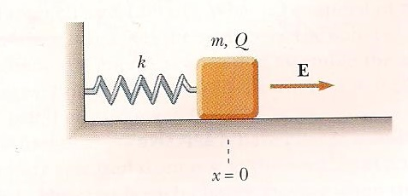

Two insulated sphere has radii r1 and r2, and charges q1 and q2. They are released from rest when their centers are d apart. What is their total kinetic energy when they collide?

CH 24

A small object of mass m and charge q is suspended in the middle of two vertical parallel plates of a capacitor. If the non-conducting string supporting the mass hangs at an angle θ, what is the potential difference between the plates?

Two capacitors when connected in parallel have an equivalent capacitance C_{p}. When they are connected in series, they have an equivalent capacitance C_{s}. Find an equation for (C1 + C2) and for (C1*C2).

CH 25

A long cylindrical wire lies along the x-axis. It has length L, diameter d, and resistivity ρ. The potential at x=0 is V, the potential at x=L is zero. In terms of L, d, V, ρ,
a. What is the electric field in the wire?
b. What is the resistance in the wire?

CH 26

When two unknown resistors are connected in series with a battery of fixed potential difference V, the battery delivers a power P_{s.} When two unknown resistors are connected in parallel with the same battery, the battery delivers a power P_{p}. What are the values of the unknown resistors?

CH 27

A rod of mass m and radius R rests on two parallel wires that are a distance d apart and L long. The rod carries a current I (in the direction shown) and rolls along the rails without slipping. If it starts from rest, what is the speed of the rod as it leaves the rails if a uniform magnetic field B is directed perpendicular to the rod and rails?

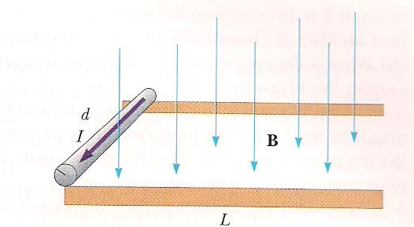

CH 34

The distance between an object and its upright image is d. If the magnification is M, what is the focal length of the lens being used in terms of d and M?

CH 35-36

Consider the two slit experiment shown in the figure. A sheet of transparent material of thickness t and index of refraction n is placed in front of one slit. As a result, the central maximum is shifted a distance y’ on the screen. Find y’.

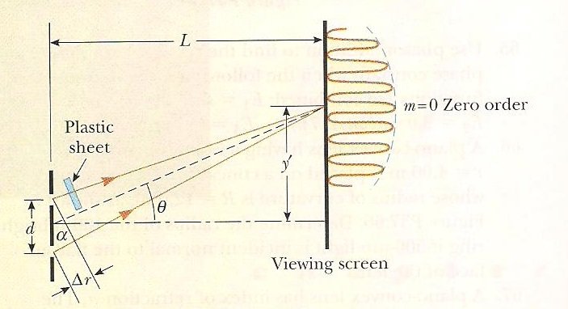

Suppose that you are standing on a straight, level piece of highway and watching a car move away from you at a speed v. The air is perfectly steady and clear. After a time t, the tail lights appear to merge into one light. Assuming the diameter of the pupil of your eye is d, estimate the width of the rear end of the car.

