SYLLABUS

ISC 211: LIVING ON THE EARTH

SPRING SESSION 2014

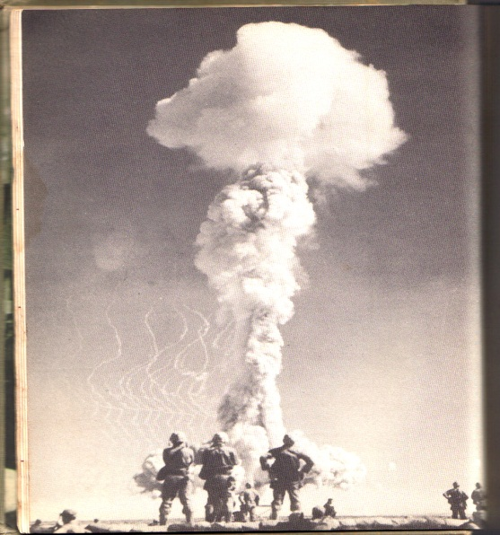

Instructor: Terry Shank
Office: Room 113, Morrow Library
Phone: Office: 696-3517 email: shank@Marshall.edu

Office Hours | : MWF: 9:30 – 10:30 am, MW:12:30-3, MW: 4:30-5:30  TR: not on campus  Other times by appointment ONLY
COURSE DESCRIPTION:
The title “Living on the Earth” is a rather nebulous phrase that intends to combine the disciplines of Biology, Chemistry, Physics, Geology, Mathematics, Astronomy, Anthropology and other sciences in an effort to identify and explain problems that have the potential to alter environments on the Earth. Many of these problems/conditions are the sole responsibility of the human inhabitants, yet others come from far beyond the reach of human hands. The focus of this course will be on humans as agents of evolution (if we may be so bold as to assume), agents of species dispersal, agents of extinction and agents of perturbation of the Earth’s many ecosystems structure and function.

COURSE OBJECTIVES:
1) The student will learn the methodology of science, stressing the significance of the “Scientific Method’ as a means of obtaining meaningful information about the diversity and unity found on the Earth.
2) The student will learn how to apply scientific skills to allow him to better distinguish fact from fiction, hearsay and myth in order to discern the value of ‘scientific’ information that is being supplied for his consideration.
3) The student will learn to interpret and apply statistical data sets as presented in charts, graphs, etc., reflecting skills developed from a prerequisite math class.
4) The student will learn to refine competencies of research and analysis into both writing and oral presentations.
5) The student will learn some of the fundamental concepts of physical and biological science.
6) The student will learn the fundamental concepts of ecology and environmental science.
7) The student will learn the perspective of man’s historic role in the alteration of his environment
8) The student will learn a prospectus of current human activities with respect to the effects these activities have on the environment
9) The student will learn about sources of change that lay beyond the influence of human activities

COURSE OVERVIEW:
- Fundamentals of science and the Scientific Method
- Fundamentals of Ecology
- Forces of change from within the Earth…and from without
- The environmental role of fire, water and weather as agents of change
- Dynamics of Hominids, including Homo sapiens
- The consequences of culture among primitive humans and the spread of civilization
- The effects of pollution on the environment, and the effects of the environment on pollutants
- The choices facing modern man, environment verses economics

There is no text for this course, so you will be provided with readings and websites as sources of information to augment lecture material. There is a plentiful supply of information, so it will be your responsibility to research and read information from these sites as they are presented to you. You will be held responsible for all classroom and lab activities. In accordance with University policy, please communicate with me via your Marshall University email address in order to avoid release of sensitive information to third parties. Assignments will also be provided through your MU email address.

COURSE EVALUATION
Classroom activities will be evaluated in the form of two (2) tests. Occasional exercises will also be graded for points, and will be used to emphasize specific lecture content and/or current events as they may arise. The mechanics of this course make it difficult to offer ‘makeup tests’, so only special requests and excused absences will be allowed. There are no provisions to makeup classroom activities, quizzes and labs. To get full credit for these activities, attendance is mandatory. As an incentive, Lecture and lab materials will be emphasized on exams. Evaluation of lab participation, two writing assignments of three pages each, outside assignments, using a variety of methods, including-but not limited to-quizzes, class participation, research opportunities and a group presentation (as explained below) will constitute the additional points used for student evaluation. All labs will be graded for points, with some labs, such as off-campus field trips, carrying more point value than others. You will need to bring a calculator for several of the labs.

GROUP PRESENTATION
Each student will participate in a group presentation based on a subject selected by yourself or your instructor. Each group will consist of no less than two nor more than four students. These presentations will be made during the final lab sessions. It will be worth a total of 100 points for each participant. A corresponding three page paper dealing with each student’s individual portion of the presentation will be due at the time of the group’s presentation. Specific instructions will be emailed at a later date.

CLASS ASSIGNMENTS
Websites and readings will be provided on a regular basis as required reading. Access to a computer is therefore a necessity. Please come to each class prepared for discussion of these assignments. Email assignments will also be given when appropriate, and will not be repeated by me in future class sessions. This will require your attendance or inquiry from other students to get the assignments and due dates. I will regularly communicate with you through your Marshall email account, so make it a habit to check it on a regular basis.

“Policy for Students with Disabilities: Marshall University is committed to equal opportunity in education for all students, including those with physical, learning and psychological disabilities. University policy states that it is the responsibility of students with disabilities to contact the Office of Disabled Student Services (DSS) in Prichard Hall 117, phone 304 696-2271 to provide documentation of their disability. Following this, the DSS Coordinator will send a letter to each of the student’s instructors outlining the academic accommodation he/she will need to ensure equality in classroom experiences, outside assignment, testing and grading. The instructor and student will meet to discuss how the accommodation(s) requested will be provided. For more information, please visit http://www.marshall.edu/disabled or contact Disabled Student Services Office at Prichard Hall 11, phone 304-696-2271.”

The Writing Center is available to help with your three page paper and any writing assignment. Please consider the following information for any writing assignment you may have during your tenure here at Marshall University. Here is some information about the Writing Center and I encourage students to visit them as you work on your writing projects:

- We are located on the 2nd floor of Drinko Library. Our phone number is 304-696-6254, and our email address is writing@marshall.edu.
- The center opens Tuesday, September 7, for the fall term.
- The center is staffed by upper-level undergraduates (various majors) and English graduate students who are trained to help students with papers in any discipline.
- We use a web-based appointment system, which students can use to make or modify their own appointments: http://www.rich16.com/mu/. Students may also walk-in to make appointments or to work with a tutor if one is available.
- We offer online tutoring via email. Students who wish to send in their work electronically can go to http://www.marshall.edu/english/writingcenter/owc/ for more information.
- We are partnering with the reference librarians to offer one-to-one research help this semester. Students can make appointments with a reference librarian just as they would with a writing tutor. Appointment slots will be designated either RESEARCH or WRITING to differentiate those services.

Please also let students know that this service is free (although they certainly pay for it in their student fees) and that we are here to guide them through their writing assignments. Tutors attempt to focus on larger issues such as thesis development, organization, depth of insight, and research first and then attend to editing issues after a solid draft has emerged. Tutors also help with brainstorming and helping students outline what they want to say, so students do not need actual writing in hand when they come to the Writing Center. Tutors can help them interpret an assignment and to map out some writing strategies.
Last, we will not have our hours of operation available until tutors are settled in with their own classes and work obligations, but I will make those available as soon as possible. We are also working on our web site (http://www.marshall.edu/english/writingcenter/), and it should be fully operational in a week or two.

LECTURE SCHEDULE: (SUBJECT TO CHANGE/REFINEMENT)

Introduction, Expectation-Yours, Mine and Ours, Discussion

Science and the Scientific Method

‘Reality, What a Concept’- the nature of matter and energy

Nitpicking Reality- atoms, molecules, bonds and such

The Theory of Evolution

An Investigation of Energy

The Structure of the Earth, Mineral Resources

Earthbound Energy Resources

Non-renewable verses Renewable Energy

Soil and Food Resources

Pesticides

Principles of Population

Human Population, Problems of Distribution

MIDTERM EXAM: Science verses Non-science Paper Due

Weather, Climate and Heat Distribution, Air as a Resource

Systems of the world: Terrestrial Biomes, Aquatic Life Zones
Air Pollution

Climate Change

Water Resources, Freshwater and Saltwater

Water Pollution

Solid and Hazardous Wastes

Environmental History of USA

Biodiversity

Sustainability, Wild Species

Sustainable Cities-Urban Land Use

Economics and Environment

Politics and Environment Waste Diary Due

FINAL: MONDAY MAY 5, 2014 3:00-5:00

LAB SCHEDULE: (SUBJECT TO CHANGE/REFINEMENT)

LAB 1: Introduction, lab safety, film

LAB 2: Scientific Method

LAB 3: Film for Science/Non-Science Paper

LAB 4: Evolution, film

LAB 5: Geology principles film

LAB 6: Energy use film

LAB 7: Campus Energy Waste

LAB 8: Energy Conservation film

LAB 9: Earth’s Carrying Capacity- bring calculator

LAB 10: SPRING BREAK

LAB 11: Population distribution

LAB 12: FIELD TRIP TO BEECH FORK (or film if weather uncooperative)

LAB 13: Sustainability film

LAB 14: Film on Public Health

LAB 15: GROUP PRESENTATIONS

LAB 16: GROUP PRESENTATIONS

