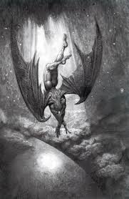 | Marshall University  Criminal Justice & Criminology  CJ 409/509: A Goth Primer for Juvenile Justice Professionals  Fall 2014 | 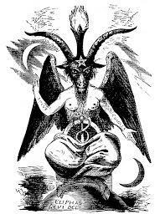
Here at least we shall be free; the Almighty hath not built Here for his envy, will not drive us hence:
Here we may reign secure, and in my choice to reign is worth ambition though in Hell: Better to reign in Hell, than serve in Heaven.” — John Milton, Paradise Lost

CJ 409/509: A Goth Primer for Juvenile Justice Professionals Fall 2014 3.0
Course Number & Title Semester/Year Credits

Dr. Gordon A. Crews Phone: 304.696.3083 (Voice Mail) Office: SH 734 Email: crewsg@marshall.edu

Professor

We will be meeting in SMITH HALL 154, big auditorium!!!!

Class Hours, Days, & Room:

Friday | October 17, 2014: 6:00 – 9:00 pm  October 24, 2014: 6:00 – 9:00 pm  November 7, 2014: 6:00 – 9:00 pm
Saturday | October 18, 2014: 9:00 – 4:00 pm  October 25, 2014: 9:00 – 4:00 pm  November 8, 2014: 9:00 – 4:00 pm
Sunday | October 19, 2014: 9:00 – 1200 pm  October 26, 2014: 9:00 – 1200 pm  November 9, 2014: 9:00 – 1200 pm

Office Hours & Days: Tuesday & Thursday 9:00 to 11:00am and 9:00 to 1:00pm

REQUIRED TEXT: There is no required text for this course (Use your money for copies, research materials, gas, weapons, bail, and other items you may need!).

COURSE DESCRIPTION: The topic for this course is an examination of the possible influence that youth involvement in alternative belief systems and practices may have upon their eventual violent, negative, criminal, and/or anti-social behavior. Special focus will be on proper responses to youth involved in the Goth, Vampire, Satanic, Wiccan, and other Occult-style lifestyles. An essential part of this focus will be an examination of the concept of “legend tripping” which involves inherently delinquent juvenile activities at geographic sites associated with some tragic event, rumored to be supernatural or related to the occult. “Satanic tourism” is a type of legend tripping characterized by juvenile involvement in pseudo-Satanic/occult behavior, such as drawing pentagrams, writing epithets, and burning candles. A juvenile may visit a geographic location such as an abandoned church, historic graveyard, or reputedly “haunted” site, and engage in mischievous, destructive, or “ritualistic” behaviors as “rites of passage.” These activities, which often are relatively harmless and conducted primarily for juvenile thrills, may be perceived by law enforcement, educator, parents, and the larger community as threatening and dangerous. A special presentation of photos and stories of legend trip sites and associated juvenile delinquency across the country will be given. This course will also involve actual field research where students investigate their own legend trip site and/or behavior.

COURSE LEARNING OBJECTIVES MATRIX

Course Objectives | How Practiced in this Course | How Assessed in this Course
- Students will critically analyze and evaluate the myriad of Goth and Alternative Belief Systems of interest to youth | Assigned readings, course lectures, required library research, and video presentations | Student lecture, mid-term, class discussion participation, and final exam
- Students will critically analyze and evaluate the concept of “Satanic Tourism” and its connection to juvenile delinquency actions, attitudes, and noticeable variances in security staff | Assigned readings, course lectures, required library research, and video presentations | Student lecture, mid-term, class discussion participation, and final exam
- Students will critically analyze and evaluate the connections between “Identity Work” and juvenile delinquency | Assigned readings, course lectures, required library research, and video presentations | Student lecture, mid-term, class discussion participation, and final exam
- Students will critically analyze and evaluate the concept of “Legend Trips” and their connection to juvenile delinquency | Assigned readings, course lectures, required library research, and video presentations | Student lecture, mid-term, class discussion participation, and final exam
- Students will critically analyze and evaluate the the hysteria and public perceptions relating to juvenile involvement with the Occult & Satanism | Assigned readings, course lectures, required library research, and video presentations | Student lecture, mid-term, class discussion participation, and final exam
- Students will identify the international ramifications of conflicts caused by juvenile involvement | Assigned readings, course lectures, required library research, and video presentations | Student lecture, mid-term, class discussion participation, and final exam

GRADING SCALE: A = 90 – 100 B = 80 – 89 C = 70 – 79 D = 60 – 69 F = 59 and below
EVALUATION OF LEARNER OBJECTIVES/COURSE REQUIREMENTS (Grades will be based on the following requirements):

Undergraduate Requirements and Score Sheet
Requirement | Points | Your Score | Due Date
Student Participation (8x25) | 200 |  | Each class meeting
Site Portfolio | 300 |  | November 8, 2014
Site Presentation | 200 |  | November 8, 2014
Final Exam | 300 |  | November 9, 2014
Total Possible Points | 1000

Graduate Requirements and Score Sheet
Requirement | Points | Your Score | Due Date
Student Participation (8x25) | 200 |  | Each class meeting
Site Portfolio | 300 |  | November 8, 2014
International Goth Portfolio | 100 |  | November 8, 2014
Site/portfolio Presentation | 200 |  | November 8, 2014
Final Exam | 200 |  | November 9, 2014
Total Possible Points | 1000

- SITE PORTFOLIO (300 points): Students will be required to work in teams and develop a “Site Portfolio”. See attached information.

- SITE PRESENTATION (200 points): Students will be required to participate in a 20-30 minute presentation on their team’s site. See attached information.

- INTERNATIONAL GOTH PORTFOLIO (100 points/Graduate Students Only): Each graduate student will be required to develop a brief International Goth Portfolio. See attached information.

- FINAL (300/200 points): A final will be given on November 9, 2014. This exam will consist of questions developed from lectures and student lectures given since the beginning of the course!

COURSE OUTLINE: The below outline is subject to change to meet the needs of the class.

Course Schedule
Date & Time | Lecture Topics/Discussions | Video Selections
Weekend 1
October 17, 2014: 6:00 – 9:00 pm  October 18, 2014: 9:00 – 4:00 pm  October 19, 2014: 9:00 – 1200 pm | Overview  - Introduction to Course  - Endarkenment: A Journey  - Satanic Tourism & Legend Trips  - Legend Tripping as Field Research  - “Goth: The Game”  Historical Perspectives  - A Brief History of the Occult  Definitions and Views  - What is Goth?  - Analysis of Student Writings  - Levels of Involvement  - Viewpoints: Rational vs. Irrational | - “Legend Trip Production Video”  - “Salem Witch Trials”  - “Geraldo: Exposing Satan’s Underground”  - “Geraldo: Satanic Baby-Breeders”  - “Paradise Lost: The Child Murders of Robin Hood Hills”  - “Paradise Lost 2: Revelations”  - “Dateline: Occult Books and Literature”  - God Vs. Satan
Weekend 2
October 24, 2014: 6:00 – 9:00 pm  October 25, 2014: 9:00 – 4:00 pm  October 26, 2014: 9:00 – 1200 pm | Belief Systems  - Paganism  - Satanism  - Vampirism  - Witchcraft, Wicca, and the 13. Old Religion  - Voodoo & Santeria  International Aspects/Music Connections  - International Experiences: The Music Connection  - International Responses  - Art Imitates Life: Violence and Black Metal & Gangster Rap  - Black Mettalers and Gangster Rappers: Anti-Cultures  - Goth Lyrics | - “HBO: The Vampire Murders”  - “A Unique Life: Wiccans”  - “HBO: Witchcraft in America”  - “America’s Most Wanted: Vampire Groups”  - “A&E: Vampire Subculture”  - “Rock n Roll Murder: When Lyrics Lead to Murder”  - “Norwegian Black Metal Documentary”
Weekend 3
November 7, 2014: 6:00 – 9:00 pm  November 8, 2014: 9:00 – 4:00 pm  November 9, 2014: 9:00 – 1200 pm | Explanations/Solutions  - Theoretical Aspects  - A Framework for Understanding  Team Presentations  Wrap-up and Final Exam | - “Bang Bang, You’re Dead”

SITE PORTFOLIO (See Investigation Report form at the end of syllabus)

Each student will be required to serve on a team of at least two members to research and document AT LEAST one “Legend Trip” site. The documentation must be presented to the instructor no later than NOVEMBER 8, 2014 in the following fashion:

Site Portfolio must consist of the following (must be placed neatly in an ACCO type file folder):

- Title page (listing the name of the student and site location information)
- A photo of yourself while at one of these sites
- All appropriate forms & interviews filled out and in order (will be given out in class)
- All information pertaining to the site neatly displayed so that it is easy to read (examples will be given in class)
- All photographic documentation (depending on the type of site or number of sites ~ it is generally expected that 10 to 12 photos should be taken at each site)
- An addendum of any addition information of interest relating to the site
- A two page typed written brief discussion of what you found most interesting about this research

The purpose of this project is to gather information from a number of resources through actual field research.

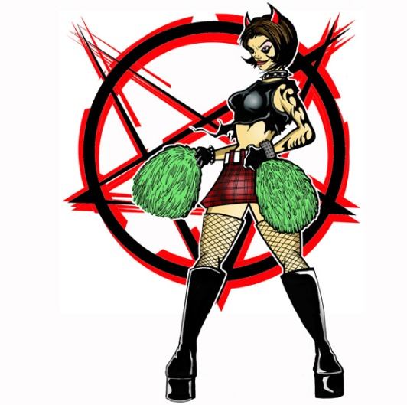 SITE PRESENTATION
Each student team will be required to give a 20-minute presentation to the class based on the findings of their research. This presentation should include the following at a minimum:

- An overview of the site(s) documented
- A discussion of the history associated with the site(s)
- A discussion of the current problems originating from the site(s)
- A discussion of interviews with law enforcement & locals familiar with the site(s)
- A presentation of the photos collected
- Personal comments on your experiences in doing this project

RESEARCH AND CLASS PARTICIPATION
Each student will be required to participate fully in every aspect of this course. You will be working in at least “pairs” but that is for safety for the most part. Class participation includes coming to all scheduled classes. You must plan on working 100% with your partner to make sure that you and your partner complete the assignments of this class. Also, you must have all sites documented, portfolio developed, and photographs developed by date of presentation.

Due to the short timeline on this course ~ there will be no make-ups on any part of the course … not enough time. If any of this seems too much for you, it is your responsibility to drop the course immediately.

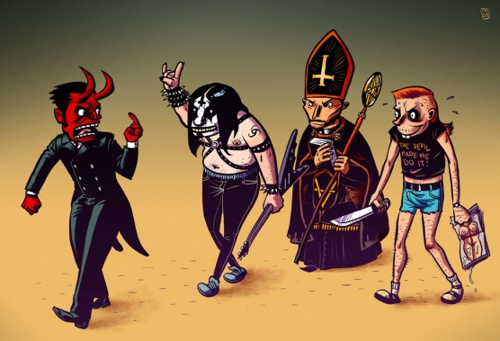INTERNATIONAL GOTH PORTFOLIO (Required for Graduate Students Only!)

Here is a chance to be used, yet become famous! I am currently working on a new text for Taylor and Francis entitled, “Youth Involvement in Alternative Subcultures, Groups, Belief Systems, and Lifestyles: Examining International Police and Societal Response.” This will be the first of its kind in that there is currently no comprehensive book examining how youth involved in such things as Goth and so forth, are treated and dealt with around the world.

I have never involved students in my publications before, but thought this would be fun and give all of you some exposure out there. Those that participate will be acknowledged and referenced fully as a contributor in this manuscript (ASAP).

Here is the very basic synopsis of the work:

This text comparatively examines relationships in the United States, Eastern and Central Europe, Scandinavia, and parts of the Middle East among juvenile violence, "heavy metal" music, substance abuse, and participation in occult and "alternative" youth groups (e.g., Wicca, Satanism, vampirism, Goth). We trace the movement of certain groups, behaviors, and preferences (e.g., heavy metal music, Black Circles) and make a correlation between some of these movements and an increase in youth violence and substance abuse in certain countries. The authors use results from surveys and participant observations in the U.S., Copenhagen, Germany, the Netherlands, & the Middle East (Egypt & Turkey) that indicate, however, that mere participation in these groups and lifestyles may not be directly related to violence and other problems such as substance abuse. Instead, societal and police response may contribute to feelings among the youth of being ostracized and socially isolated, which may, in turn, contribute to the development of violence and other anti-social behaviors. We provide suggestions for police and societal responses that may alleviate the potential for relatively harmless youth participation in these groups and lifestyles to escalate into something more threatening and harmful, both for society and for the involved youth.

My thoughts are that each graduate student would pick one country in the world (anywhere except the United States) and develop a portfolio of material dealing with what is going on in these areas involving youth. You will need to focus on the angle that is being presented above as you collect information. We will discuss format further, but I do NOT want 25 page papers, instead I want real material that you can find (HOWEVER you can find it!).

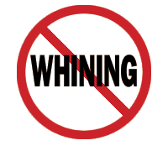

Crews’ Nine Academic Rules of the Earth

- Classroom Conduct:

- As a general rule, I, 1) show up for class, 2) arrive on time, 3) am semi-prepared, 4) sober/conscious, 5) stay off my cell phone, 6) am interested in the topic of the day, and 7) STAY THE ENTIRE TIME ~ I expect the same of you!!!!

- All cell phones must be turned off and put away (out of view) at the commencement of class, with the exception of emergency service personnel. Cell phones are disruptive not only to me, but your fellow students, so please be courteous. You will receive only one warning if your cell phone goes off in class, or if I catch you playing with it during class.

- You may NOT eat during class. This means food of any kind (chips, sandwiches, candy, etc.). However, drinks are permitted (non-alcoholic of course). Also, you should not be working on anything not related to this class once class commences (this includes reading, copying other’s notes, knitting, playing games on your cell phone, etc.).

- Do NOT leave the classroom once class has started, unless it is an absolute emergency or you have notified me before class that you will be leaving. You should use the restroom, get a drink of water, and make a phone call, etc. before class starts.

- Do NOT bring weapons into the class. If you are a law enforcement officer and required to be armed, please let me know.

- You are not allowed to smoke within the building, and I will not permit smokeless tobacco in my classroom.

- Attendance and Student Participation:

- While I do not require much when it comes to an attendance policy, I do not offer much either. This is to say that I generally do not take role except on days where an exam or in class writing assignment occurs. Although on these days NOTHING CAN BE MADE UP (without proper documentation as stated in Make-up policy). Also, I do NOT give out my lecture notes to anyone for any reason, nor do I allow any make ups for course requirements missed without proper documentation.

- Don’t hesitate to ask questions, the dumbest question is the one not asked! If you ask a question I can’t answer, I’ll find out the answer and get back to you. Please remember that as a teacher, I am merely your guide through the field, I am not the field itself! (Although, my wife would say I think I AM!).

- During discussions please respect different viewpoints; there is always more than one side. Treat others’ views as you would want your own to be treated, with an open mind. Personal attacks on others will not be tolerated!

- I like to run my classes as an open forum where we can all learn from each other, so I encourage intelligent discussions, questions, and comments, but at the same time we have to remember that we are at a university setting and must act accordingly.

- Professor and Student Responsibilities:

- I realize that every now and then, unexpected and difficult situations arise. However, when you enrolled in this class, you made a commitment to me, to yourself, and to your fellow classmates. I expect you to fulfill that commitment to the best of your ability. If you are unable to fulfill my expectation, I am really not interested in your reasons. That does not mean that I am cold and heartless, just that I have established standards for my classes that I know work from many years of experience.

- Experience has shown that it is impossible for students who miss class to pass this course. However, the reverse is also true. Those students who do not miss class and who submit work on time generally score quite high. This course is one that builds from meeting to meeting and one concept to another and requires that previously covered material be understood before one can reasonably expect to move to the next. Attendance is therefore expected. Attendance will be taken at various points during the term. Students who are not present when attendance is taken will not be credited with attending class on that day.

- Make up Policy:

- There will be no excused absences on exam days and no assignments can be made up! Any paper/project/in class work not turned in/completed on the date and time specified in the syllabus will receive a zero. Only documented medical emergencies will be considered as reasonable excuses for allowing a paper/project to be turned in late, an exam made up, or a presentation delayed, all others will be given a zero. Due dates are set in the course schedule for turning in projects and for giving presentations ~ due to the nature of these requirements, they cannot be made up.

- Extra Credit:

- At various points during the semester the instructor MAY offer opportunities for students to gain extra credit points. These are generally onetime events which reward students who take advantage of opportunities to attend out of class presentations or complete assignments in class. These can NEVER be made up; there is ample opportunity in this class for each student to obtain more than enough points to achieve an “A” ~ therefore, opportunities are a PRIVILAGE not a RIGHT and at the instructor’s discretion.

- Office Hours:

- I encourage all my students to make use of my office hours, they are there for you. If you can’t make it at the scheduled times, let me know and we can arrange to meet at another time. However, this invitation is only for those students who come to class on a regular basis and put forth a genuine effort to learn. Also, please keep in mind that I have a life too (albeit, dark and demented), and while my office hours are mandatory, my other time is not, so my flexibility can only extend so far.

- Course Materials:

- A syllabus with a detailed schedule is provided for each course, the instructor will do their utmost to follow the syllabus and it is expected that the student will as well. All due dates are listed and will be enforced (do not ask for them to be altered for any reason). Most lectures will be on PowerPoint. These presentations will generally occur one time in the course while the material is being discussed in class. I may post online lecture shells for you to use.)

- Cheating, Plagiarism, and General Academic Dishonesty:

- Don’t cheat or plagiarize! Academic dishonesty is something I take very seriously and will not tolerate. Anyone caught cheating or plagiarizing will automatically receive a failing grade for the course and will be referred to the dean for appropriate disciplinary action. Plagiarism from the internet has become a very serious problem and professors now have access to various software programs to identify this behavior, so at this point in your academic career, don’t risk it!

- University Policies/Instructor Prerogative:

- University ADA Statement: The American with Disabilities Act has established a robust set of Federal Regulations that ensure employees and students receive fair and reasonable accommodations as they work and study. It has been my experience that students with disabilities exert considerable effort to achieve their educational goals. Moreover, I have found the accommodations to represent efforts in good pedagogy rather than special treatment for the student. As such, I hope each of you will work collaboratively with the Office of Disabled Student Services as the need arises.
- Any items or events not covered in this syllabus will be handled according to established university policies and/or instructor’s prerogative.

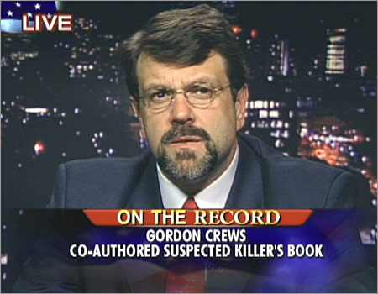 Brief Faculty Member Biographical Sketch

Dr. Gordon A. Crews is a Professor of Criminal Justice & Criminology in the Department of Integrated Science and Technology at Marshall University (WV). Dr. Crews began his teaching career in 1990 as department head of the Criminal Justice & Paralegal program at Sumter Area Technical College (SC) at twenty five years old while still in graduate school working towards his Master of Criminal Justice Degree. He would complete his first seven years of teaching at the community college level by then moving to Midlands Technical College (SC). Since 1997, Dr. Crews has served as a faculty member and/or academic administrator at the University of South Carolina Beaufort (SC), Valdosta State University (GA), Jacksonville State University (AL), Roger Williams University (RI), Cameron University (OK), and Washburn University (KS).

In addition to over 23 years of post-secondary education experience, Dr. Crews has conducted POST certified training in South Carolina, Georgia and Alabama in the areas of proper police practice. He has also worked with the Turkish National Police and Ghana National Police on community policing initiatives. Most recently he has begun communication with the Japan National Police Academy on a comparison of police practices between Japan and the United States.

He earned a Ph.D. in Education/Criminal Justice, a Graduate Certificate in Alcohol & Drug Studies, a Bachelor of Science in Criminal Justice, and Masters of Criminal Justice, from the University of South Carolina (SC). He served as Executive Counselor for the Juvenile Justice Section of the Academy of Criminal Justice Sciences and as former President and member of the Board of Directors for the Southern Criminal Justice Association. In 2008 he was appointed for a three year term as the Executive Director of the Secretariat for this same organization. In 2010 he had the honor of being appointed the first President of the charter Phi Kappa Phi National Honor Society Chapter at Marshall University (WV).

Prior to teaching, Dr. Crews worked in law enforcement (in South Carolina at Richland Country Sheriff’s Department and University of South Carolina Police Department and in Georgia at Floyd Country Sheriff’s Department/Mount Berry College Police Department) as a bloodhound/narcotics k-9 officer & trainer, field-training officer, and criminal investigator (crimes against persons/sexual assault); in corrections as a training and accreditation manager; and in insurance fraud as a private licensed investigator.

His publications include refereed journal articles dealing with juvenile and school violence, Occult/Satanic involvement and youth, and various law enforcement and correctional issues. His books include Faces of Violence in America (1996), published by Simon & Schuster; The Evolution of School Disturbance in America: Colonial Times to Modern Day (1997), published by Praeger; A History of Correctional Violence: An Examination of Reported Causes of Riots and Disturbances (1998), published by the American Correctional Association; Chasing Shadows: Confronting Juvenile Violence in America (2001), published by Prentice Hall; Living in Prison: A History of the Correctional System with an Insider’s View (2004), published by Greenwood Publishers; and, his most recent book is entitled, In the Margins: Special Populations and American Justice (2008), published by Prentice Hall.

Dr. Crews has myriad current research interests/efforts in the areas of violence and resulting societal reactions. A primary project as of late 2012 is the interviewing and surveying of 78 incarcerated school violence (K-12) offenders across the United States. A secondary effort is in working on a new book with a convicted murderer on death row in South Carolina dealing with the realities of living in prison and being incarcerated in the United States. A third, and ongoing, focus is on an international comparison of police and societal response to individuals involved in alternative belief practices (e.g., Satanism, Wicca, Goth, etc.). Through these efforts, he currently has three manuscripts in process, School Shooters Speak: Incidents, Perpetrators, and Findings (Carolina Academic Press), Juvenile Delinquency and Violence: Examining International Police and Societal Response (CRC Press), and The Complete Idiot’s Guide to Living and Dying in Prison (Alpha Books).

Since 2000, he has conducted extensive field research in these areas across the United States, United Kingdom, Middle East, Netherlands, Central Europe, Scandinavia, Turkey, Ghana, Central and Eastern Europe (Greece, Macedonia, Bulgaria, Romania, Hungry, Slovakia, Austria, Czech Republic, Slovenia, Serbia, and Croatia). His most recent research was conducted in Brazil (2010), Japan (2011), and in the United Kingdom and the Republic of Ireland (2012).

Perhaps his most relevant experience which speaks to his ability as an effective expert witness in policing and correctional matters is his role as a lead police/correctional expert in a grant-funded review of police and correctional training curricula (state, county, and municipal) from more than 60 academies across the United States. This 3 year project involved evaluating all academy curricula and noting what courses were offered, their length and content, and other characteristics of the curricula, instructors, and academies. This work resulted in a complex statistical evaluation and recommendations to improve curricula and make training more effective. The results of this work have been presented at various regional and national conferences and are being developed into manuscripts for publication review in respected criminal justice journals.

Dr. Crews has also appeared as a consultant on national and international programming such as CNN, MSNBC, Good Morning America, Anderson Cooper 360◦, The Abrams Report, Nancy Grace, Gloria Van Susteren, Ghana, African National Television, and Due Diligence on Voice of Russia Radio Network.

Presentation Evaluation Sheet

Fall 2014

CJ 409/509: A Goth Primer for Juvenile Justice Professionals

Name(s): _____________________________________________

Site: _________________________________________________

Criteria for grading:

- Quality of Analysis (50): 0 10 20 45 50
(Does the presenter(s) accurately examine the topic and logically structure the parts of the presentation?)

- Intellectually stimulating (50): 0 10 20 45 50
(Does the presentation provide thought-provoking information?)

- Use of Visuals (50): 0 10 20 45 50
(Does the presenter(s) use at least 5 visuals in the presentation, PowerPoint counts as 3 visuals)

- Teamwork (50): 0 10 20 45 50
(How well did everyone work together in this team!)

Additional Comments:
____________________________________________________________________________________________________________________________________________________________

Total Points: ________

MARSHALL UNIVERSITY
Criminal Justice & Criminology

Legend Trip Documentation/Portfolio Information

SITE INVESTIGATION FORM

Investigators: __________________ Dates of Visits: _________________________________

Sources Used/Contact Information:

Description of Site:

Location of Site:

Description of Site Phenomena/Reported Occurrences:

Type(s) of Criminal Activity at Site:

Investigator’s Observations and Documentations:

